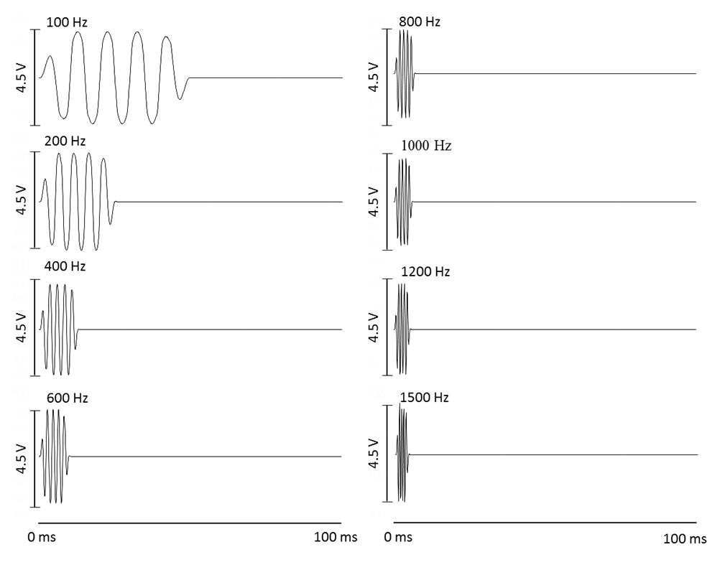
Fig S1. Tone burst stimuli used in the AEP experiment. Only one phase (90°) is shown. Each tone burst (100 ms) includes a sound wave consisting of 5-cycle waves (including one rise, one fall and three plateaus). The duration of the sound stimuli were: wave duration (ms) = 5 × 1000 / frequency (Hz). Interstimulus intervals = 100 ms - wave duration (ms). The amplitude indicates the output levels of the function synthesizer rather than the actual sound pressure.
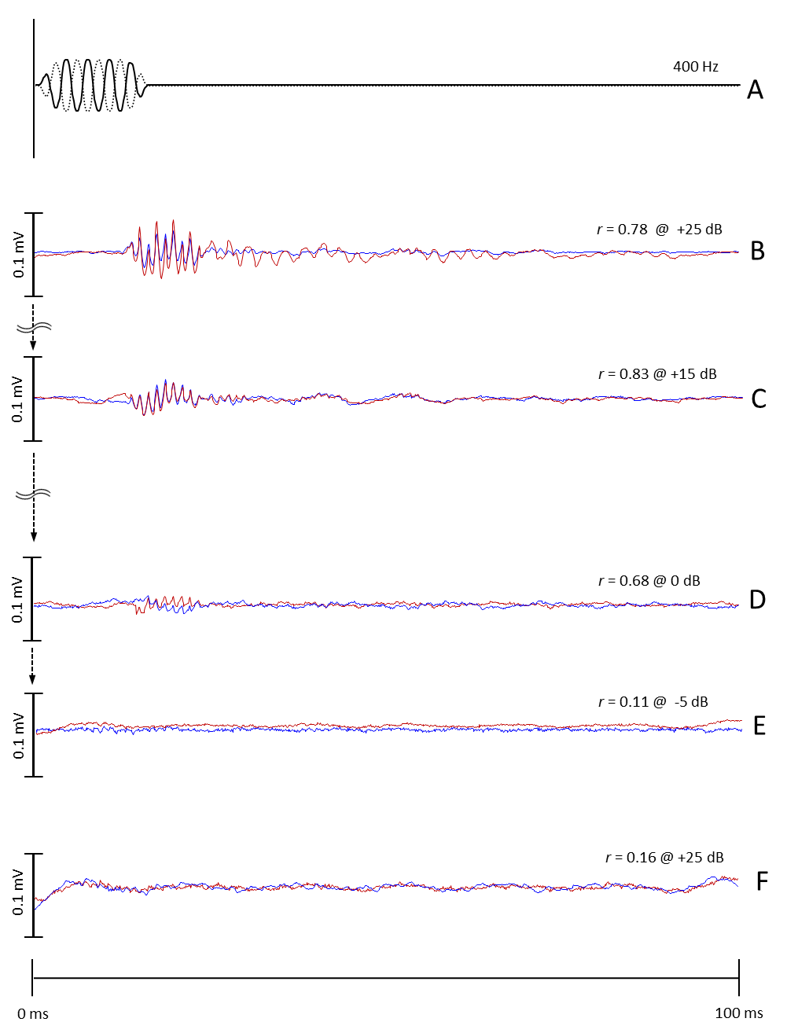
Fig S2. AEP waveforms from the black porgy (Acanthopagrus schlegelii), obtained in response to tone bursts (400 Hz) (A) of opposite polarities, 90° (solid line) and 270° (dotted line). Each experiment was initiated at the highest sound pressure level (SPL) to induce suprathreshold responses (B); the SPL was then reduced in steps of ~5 dB (B-D) until traceable and repeatable waveforms were no longer detectable (E). Recordings were performed twice for each sound stimulus (blue line and red line). The first and second ABRs were compared by calculating a correlation coefficient (r). AEPs were deemed to respond to the sound stimulus only when r > 0.3 (D, threshold: 0 dB). A recording from a dead back porgy is shown (F) under the highest sound pressure level.
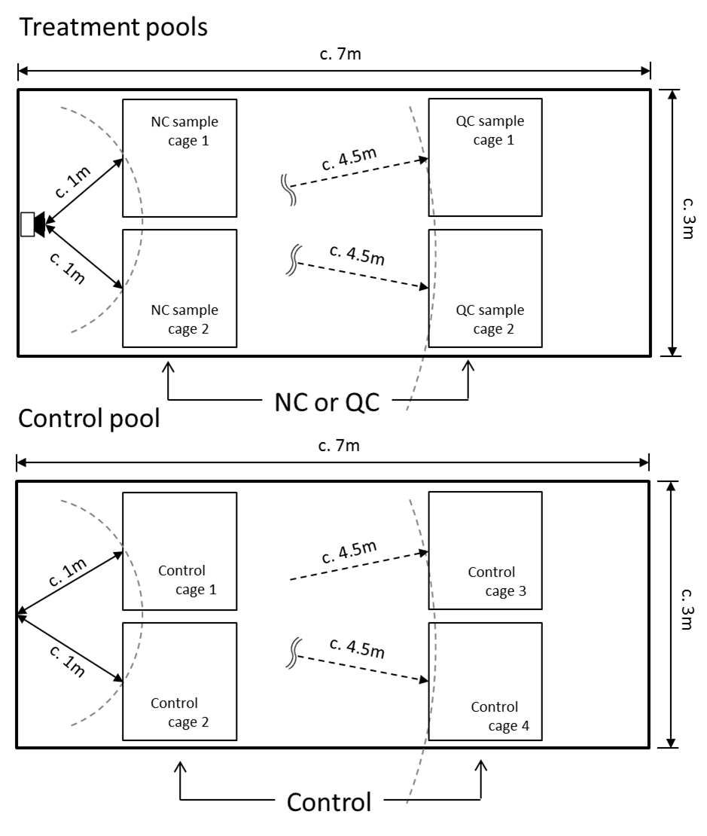
Fig S3. Diagram of the cage arrangements for the control and treatment pools.

