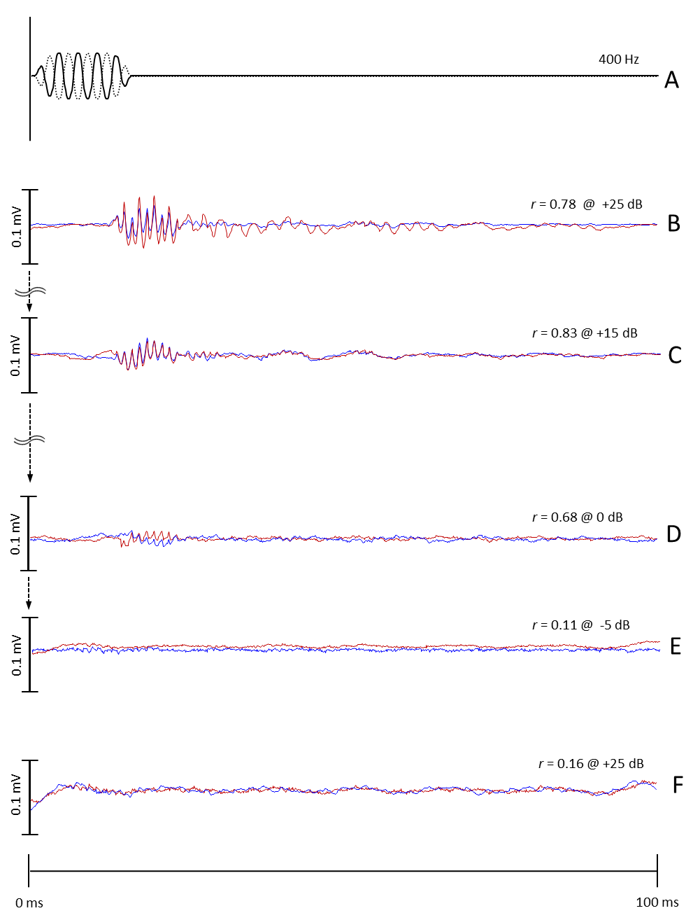
Fig S2. AEP waveforms from the black porgy (Acanthopagrus schlegelii), obtained in response to tone bursts (400 Hz) (A) of opposite polarities, 90° (solid line) and 270° (dotted line). Each experiment was initiated at the highest sound pressure level (SPL) to induce suprathreshold responses (B); the SPL was then reduced in steps of ~5 dB (B-D) until traceable and repeatable waveforms were no longer detectable (E). Recordings were performed twice for each sound stimulus (blue line and red line). The first and second ABRs were compared by calculating a correlation coefficient (r). AEPs were deemed to respond to the sound stimulus only when r > 0.3 (D, threshold: 0 dB). A recording from a dead back porgy is shown (F) under the highest sound pressure level.

