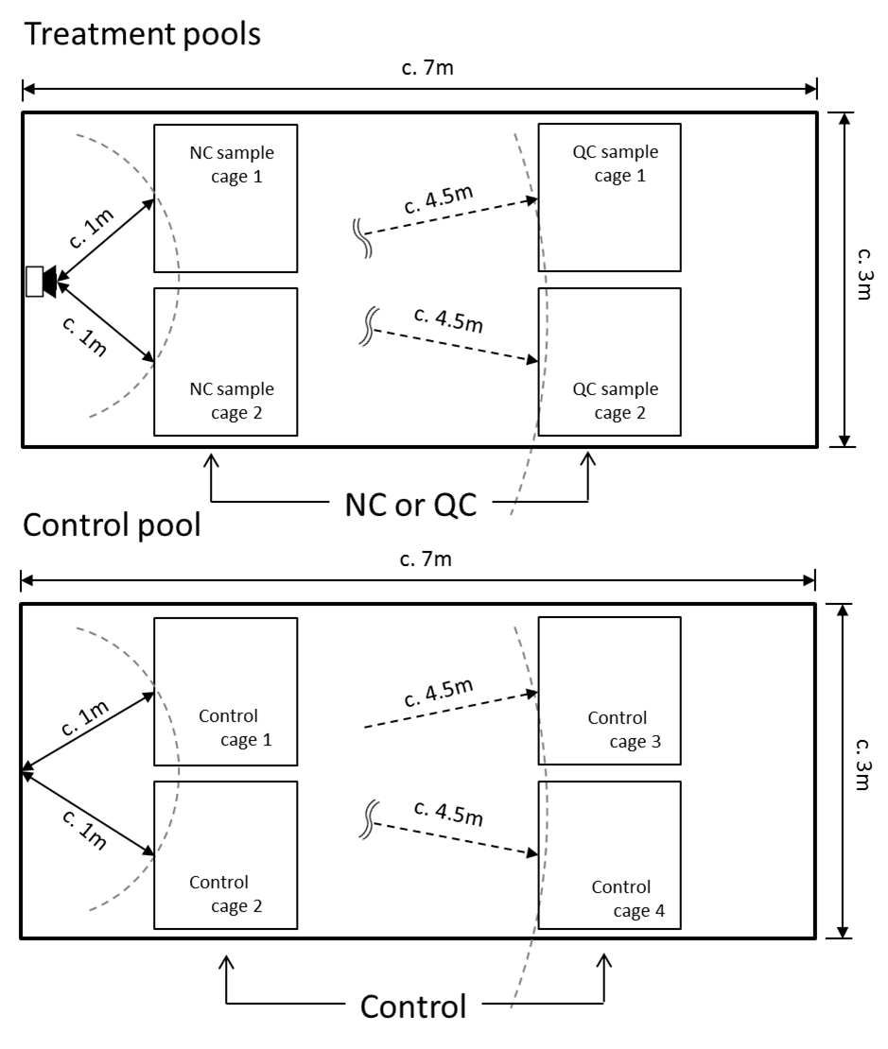
Fig S3. Diagram of the cage arrangements for the control and treatment pools.

