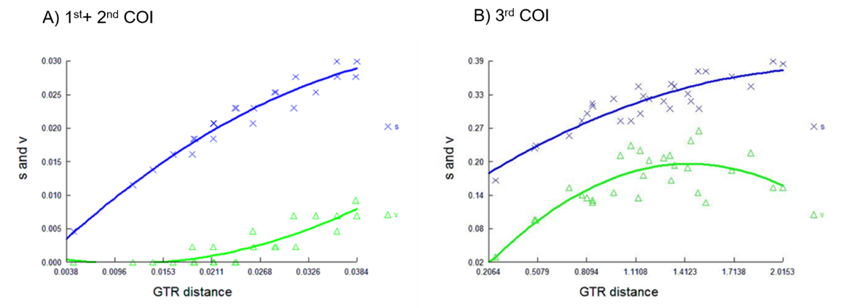
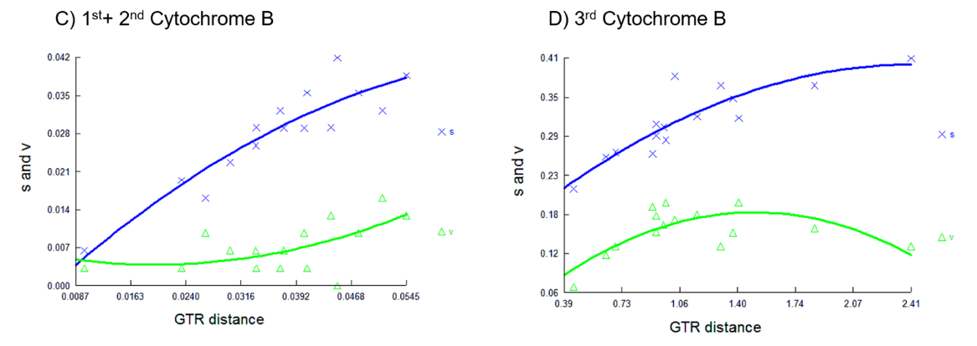
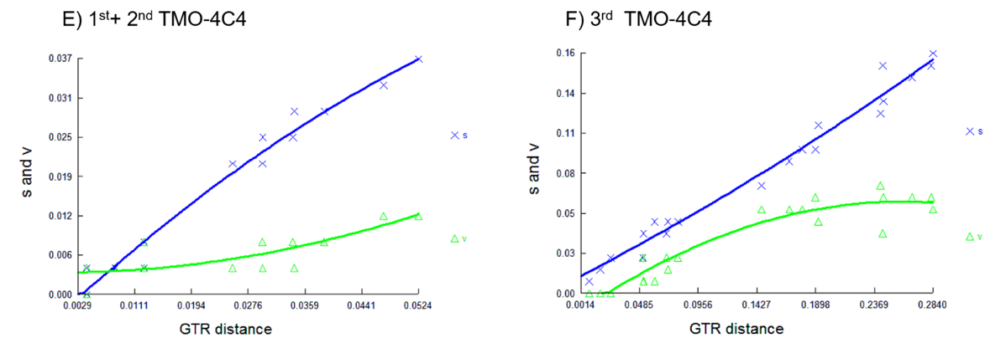
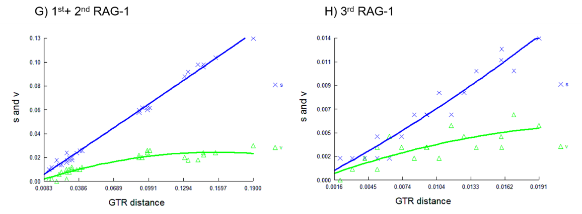
Fig. S1. Plots of transitions (blue) vs. transversions (green) for four protein coding DNA markers against corrected genetic distance (GTR), created in DAMBE5. Plots of protein coding genes show the 1st + 2nd and 3rd codon positions.

