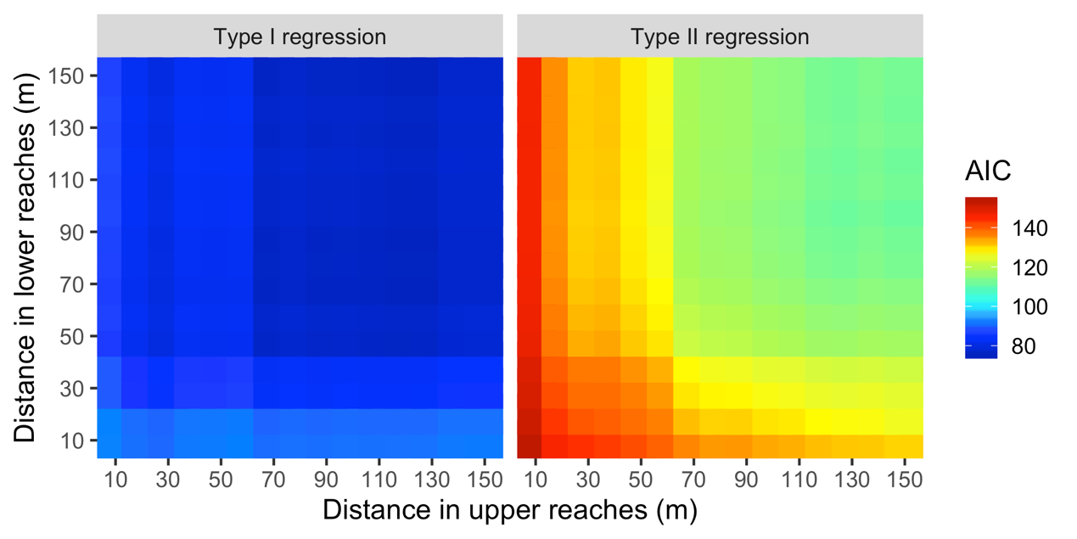
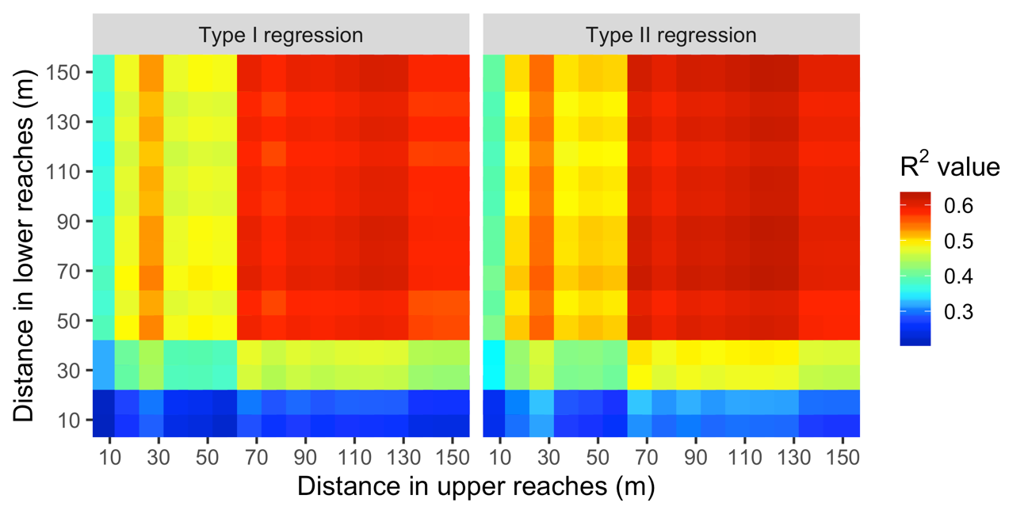
Fig. S2. Relationships between Akaike’s information criterion (AIC) or R² values and distances in lower and upper reaches that abundance of A. marmorata was calculated in the Oganeku River in the Amami-Oshima Island, Japan. AIC and R² values were calculated by a generalised linear model (GLM) and Type II regression model.

