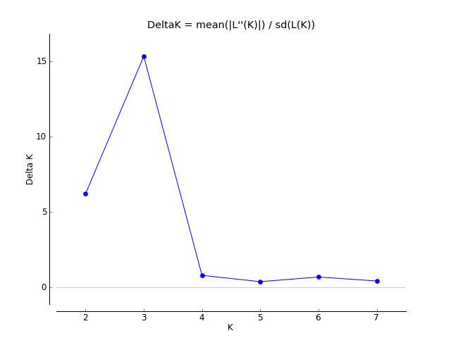
Fig. S1. Plot of Evanno’s delta K as a function of K, over 20 replicates.

