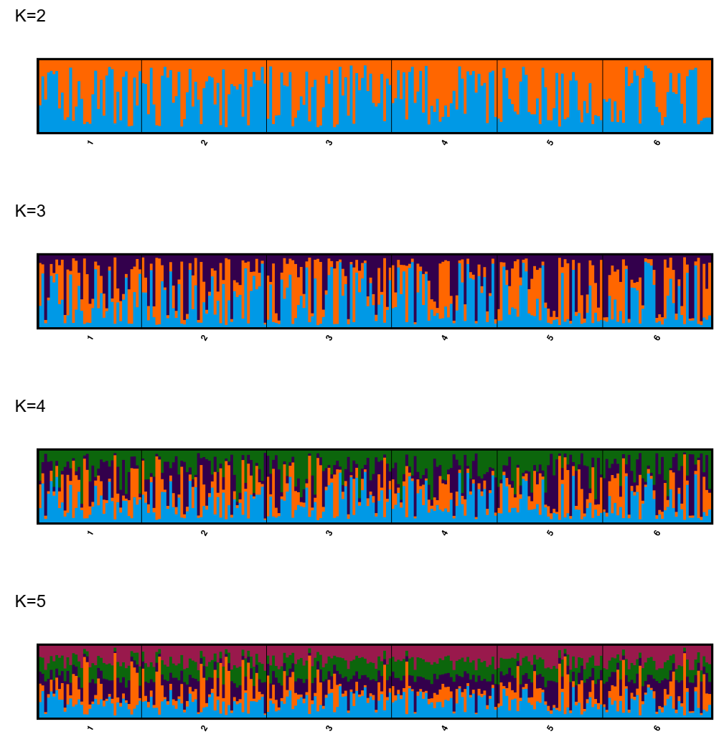
Fig. S2. SRUCTURE assignment plot of six locations of the mandarinfish with K=2 to K=5. 1: Guindacpan; 22: Handayan; 33: Inanoran; 4: Batasan; 5: Tagbilaran; 6: Palau.

