Data S1: Maxent model outputs and climatic diagrams.

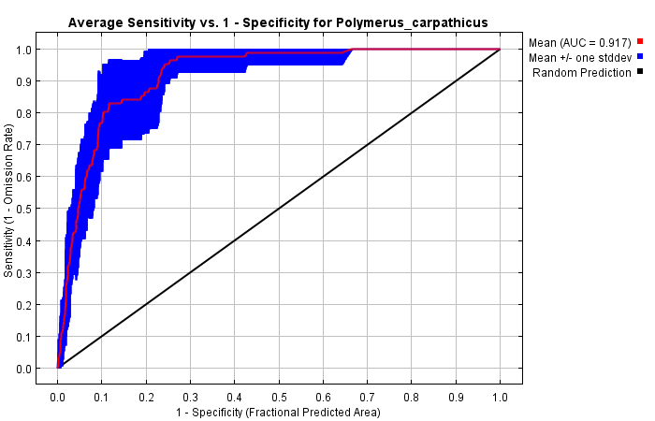
Figure S1.1. The receiver operating characteristic (ROC) curve generated in Maxent, showing an average of 10 repetitions of the model for Polymerus (Pachycentrum) carpathicus (Horváth, 1882).

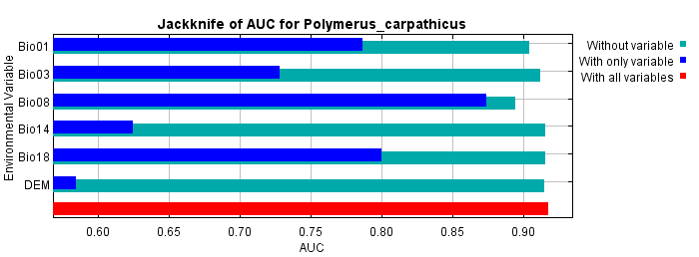
Figure S1.2. Results of jackknife test of variable importance using AUC on test data for Polymerus (Pachycentrum) carpathicus (Horváth, 1882). The jackknife test in blue bars shows individual environmental variable importance relative to the red bar, which shows all environmental variables. The light blue bar shows whether a variable has any information that is not present in the other variables, and a dark blue bar shows whether a variable has any useful information by itself. Values shown are averages over replicate runs.

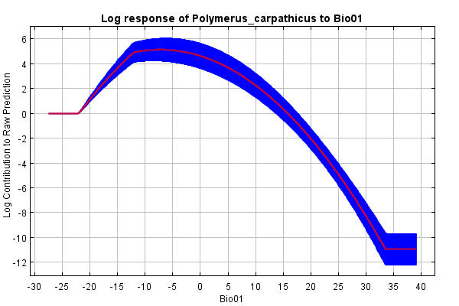

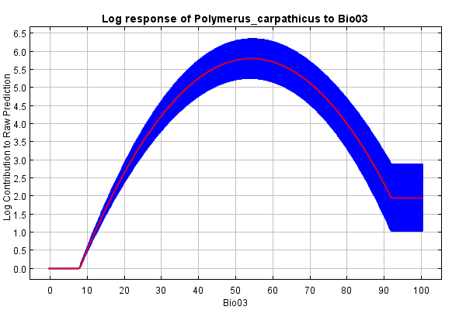

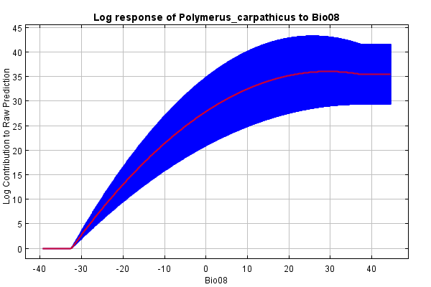

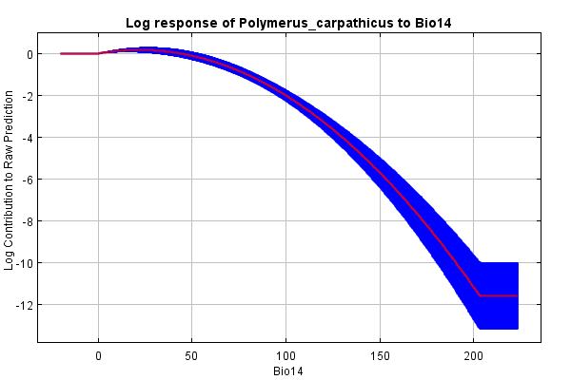

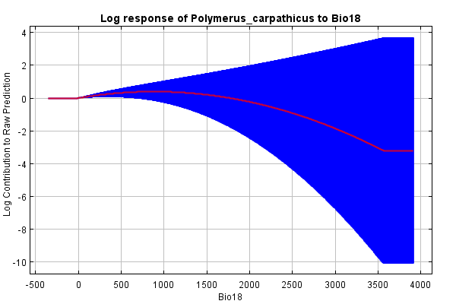

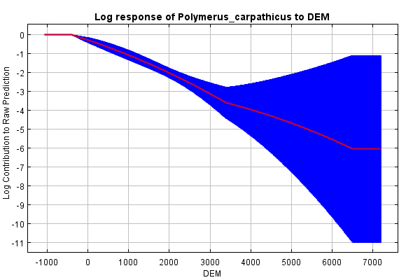
Figure S1.3. Results of response curves for selected variables for Polymerus (Pachycentrum) carpathicus (Horváth, 1882). The curves show the mean response of the 10 replicate Maxent runs (red) and the mean +/- one standard deviation (blue, two shades for categorical variables).

Figure S1.4. The climatic diagrams for Polymerus (Pachycentrum) carpathicus (Horváth, 1882). The line shows the temperature distribution during the year, and the bars represent the distribution of precipitation throughout the year. For each month, the average value from all known locations of the species is given.

Figure S1.5. Average temperature values in the coldest and warmest month in known places of occurrence of the representatives of Polymerus (Pachycentrum) carpathicus (Horváth, 1882). The occurrence points are distributed according to longitude (from Europe to Asia; from 0° to 150°E).

