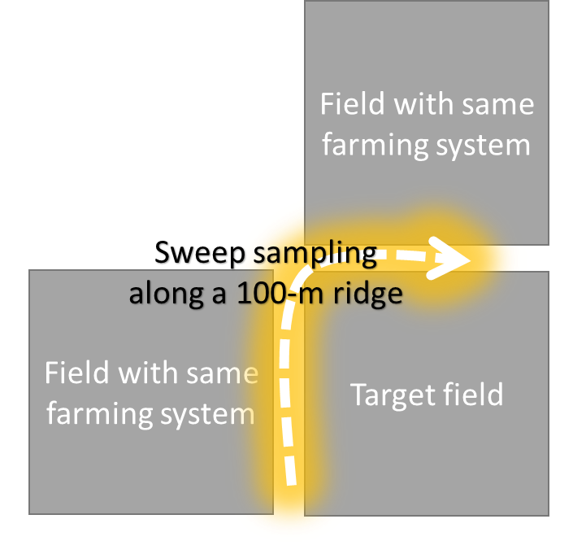
Fig. S1. Conceptual diagram of hand-net sweep sampling in this study.

