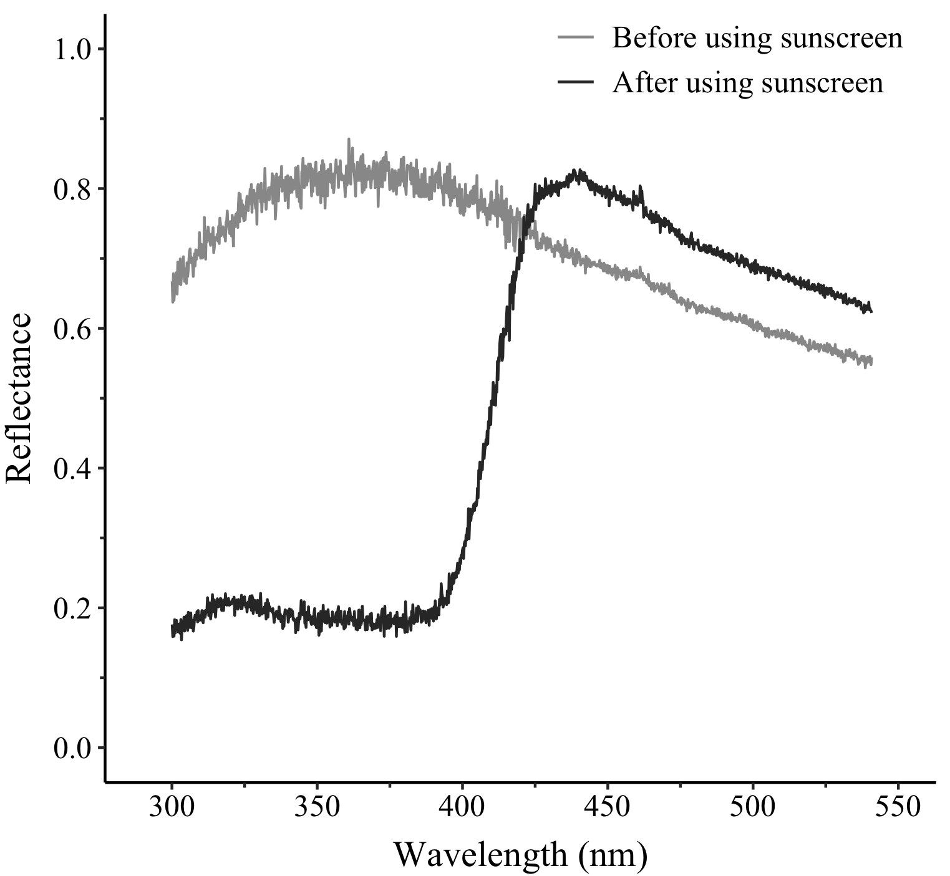
Fig. S1. The reflectance on the major claw of male A. lactea with sunscreen treatment. This plot showed the wavelength from 300 to 550 nm.

