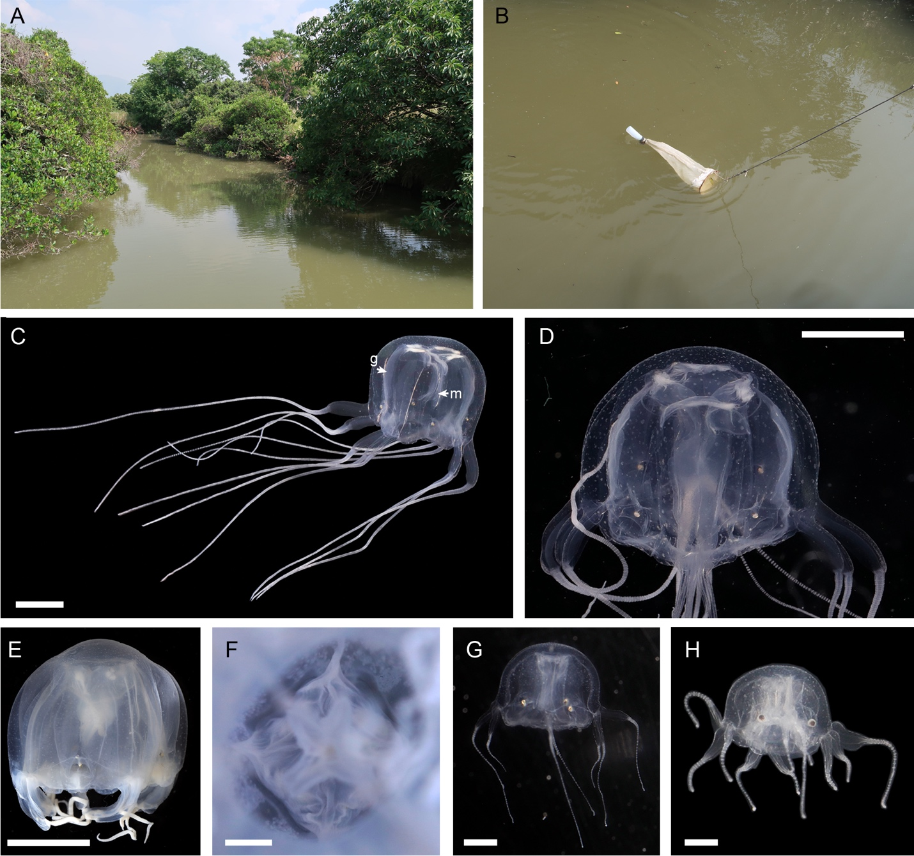
Fig. S1. Habitat and morphology of Tripedalia maipoensis sp. nov. A, A brackish water shrimp pond in Mai Po where the samples were collected. B, Sampling using a plankton net from the shrimp pond. C–D, Paratype TMBC030992, living specimen, lateral view, male. E, Paratype TMBC030992, fixed in formalin and later transferred to ethanol for preservation. F, Paratype TMBC030992, preserved, showing gastric phacellae, bottom up view. G–H, Juveniles, living specimens. Scale bars: C–E = 1 cm; F–H = 1 mm. Abbreviation: g, gonad; m, manubrium.

