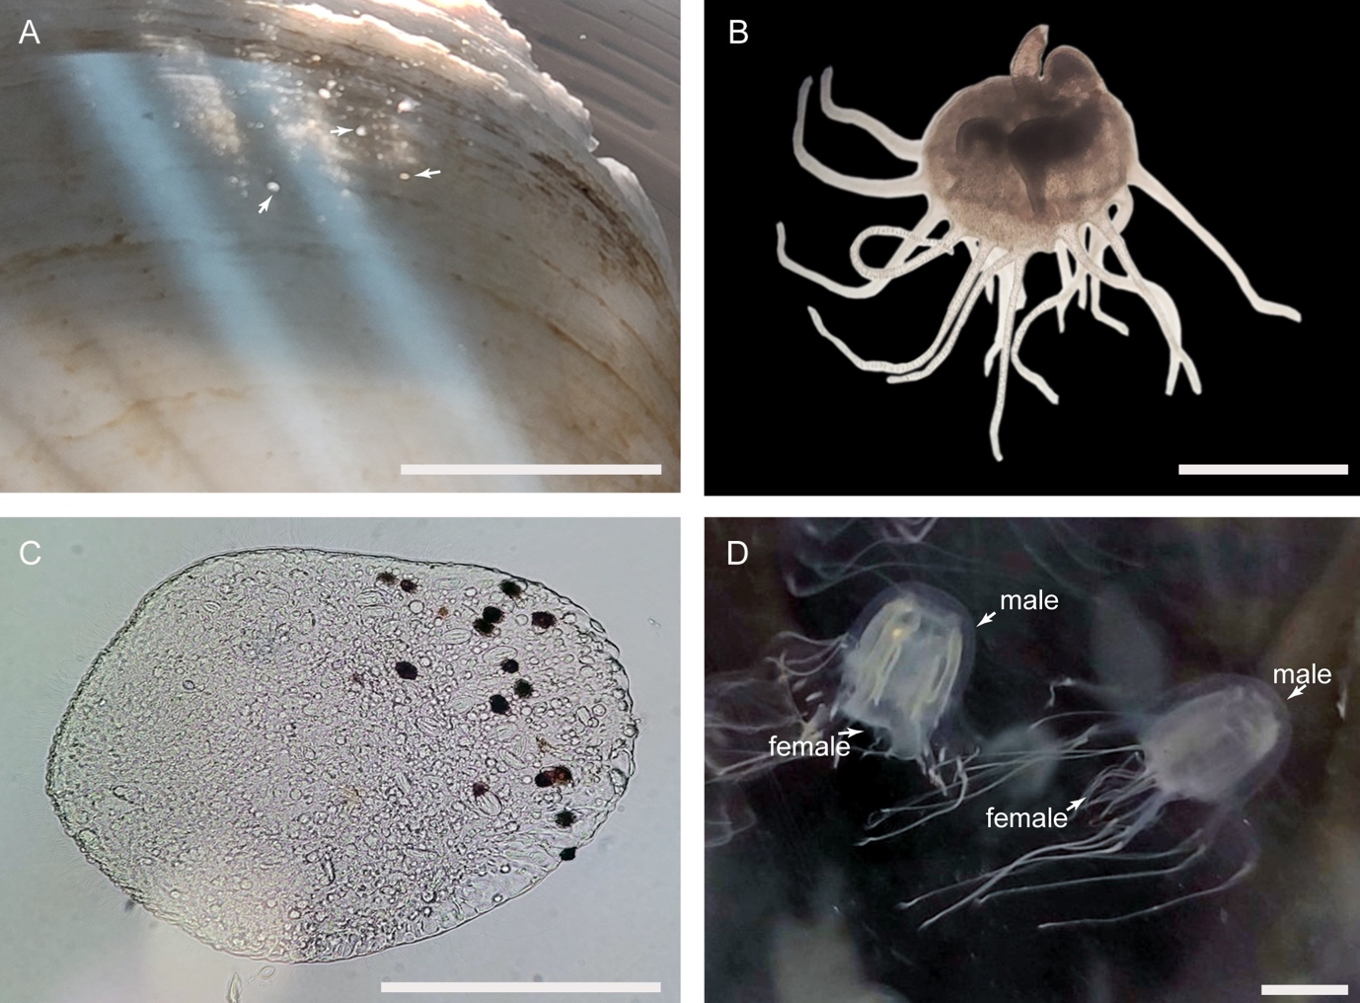
Fig. S2. Laboratory culture of Tripedalia maipoensis sp. nov. A, Polyps found on a scallop shell. B, Polyps viewed under a microscope. C, A planula viewed under a microscope. D, Two suspected mating pairs: both show a female located inside the bell of a male. Scale bar: A, D = 1 cm; B–C = 1 mm.

