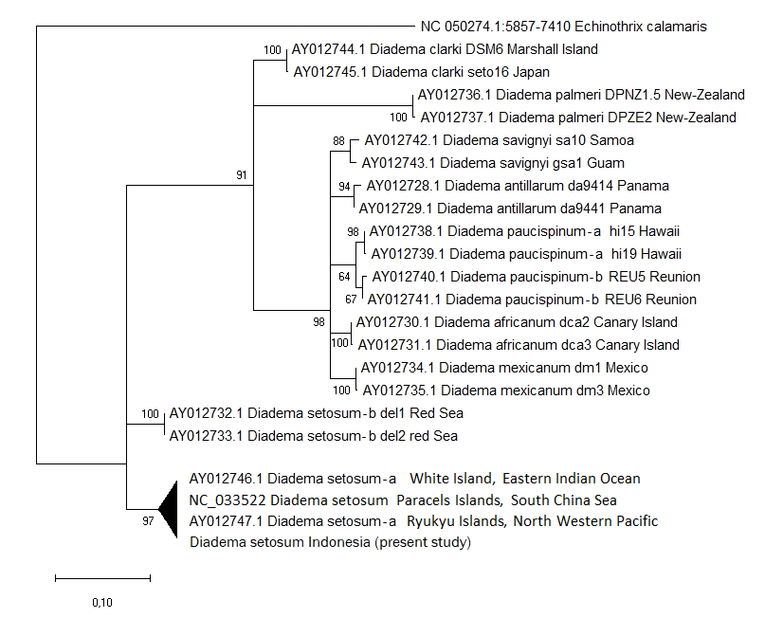
Fig. S1. Maximum-likelihood tree of Diadema spp. partial nucleotide sequences of the COI gene, rooted by homologous sequence in Echinotrix calamaris. Placement of D. setosum sequences sampled from the Indo-Malay archipelago (present study).

