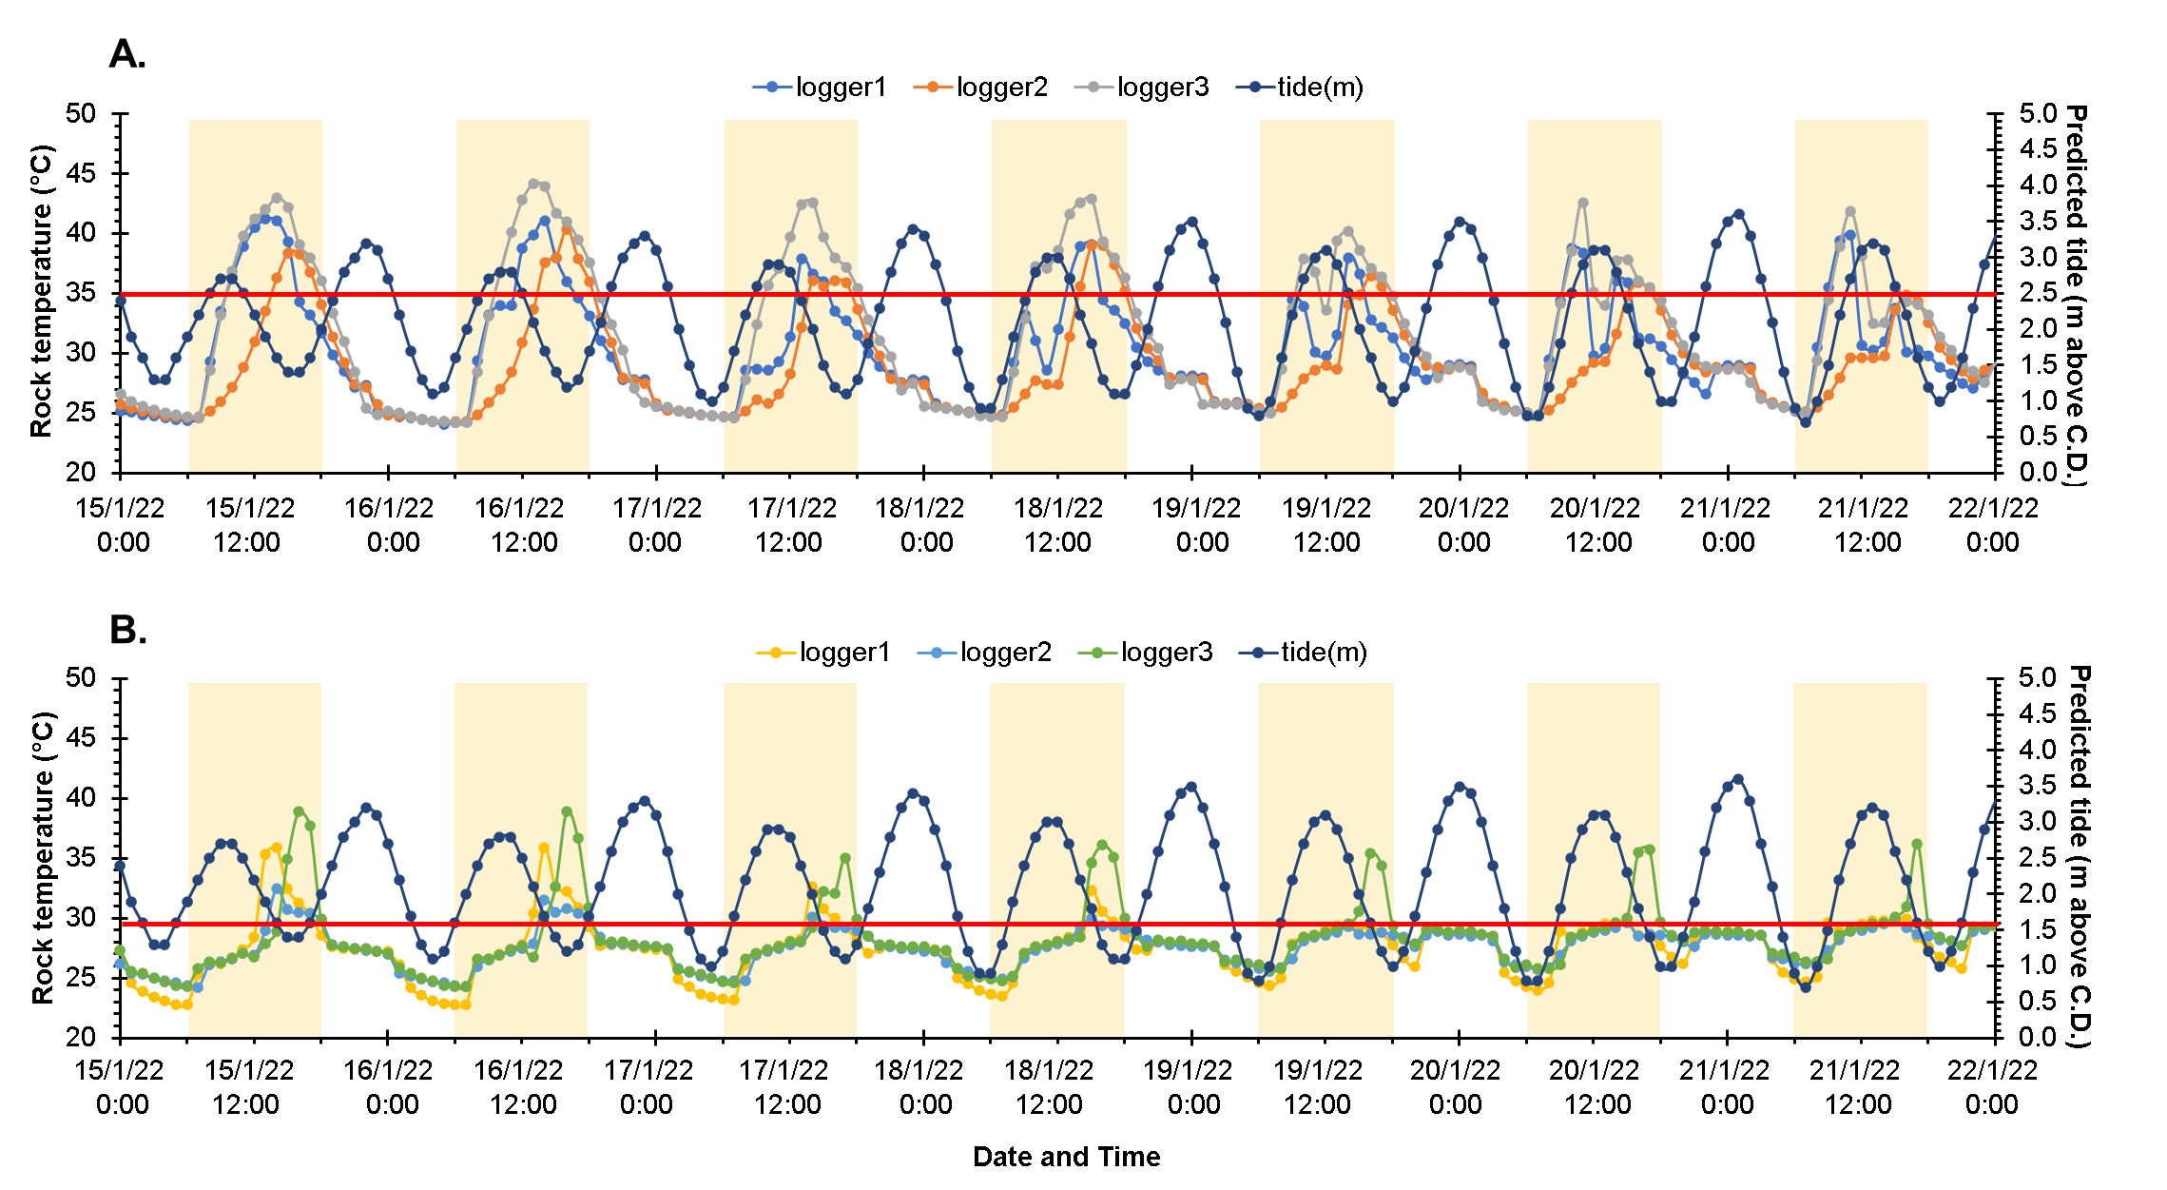
Fig. S1. Hourly temperatures recorded of Envloggers (n = 3) deployed at Phra-ae during the spring tide (15th–21st January 2022) were plotted against the predicted tide. Red lines indicate loggers’ height, which is either the most abundant level of S. guamensis (A, at 2.5 m above C.D.) or P. saccharina (B, at 1.6 m above C.D.). The yellow highlighted blocks indicate daytime periods.

