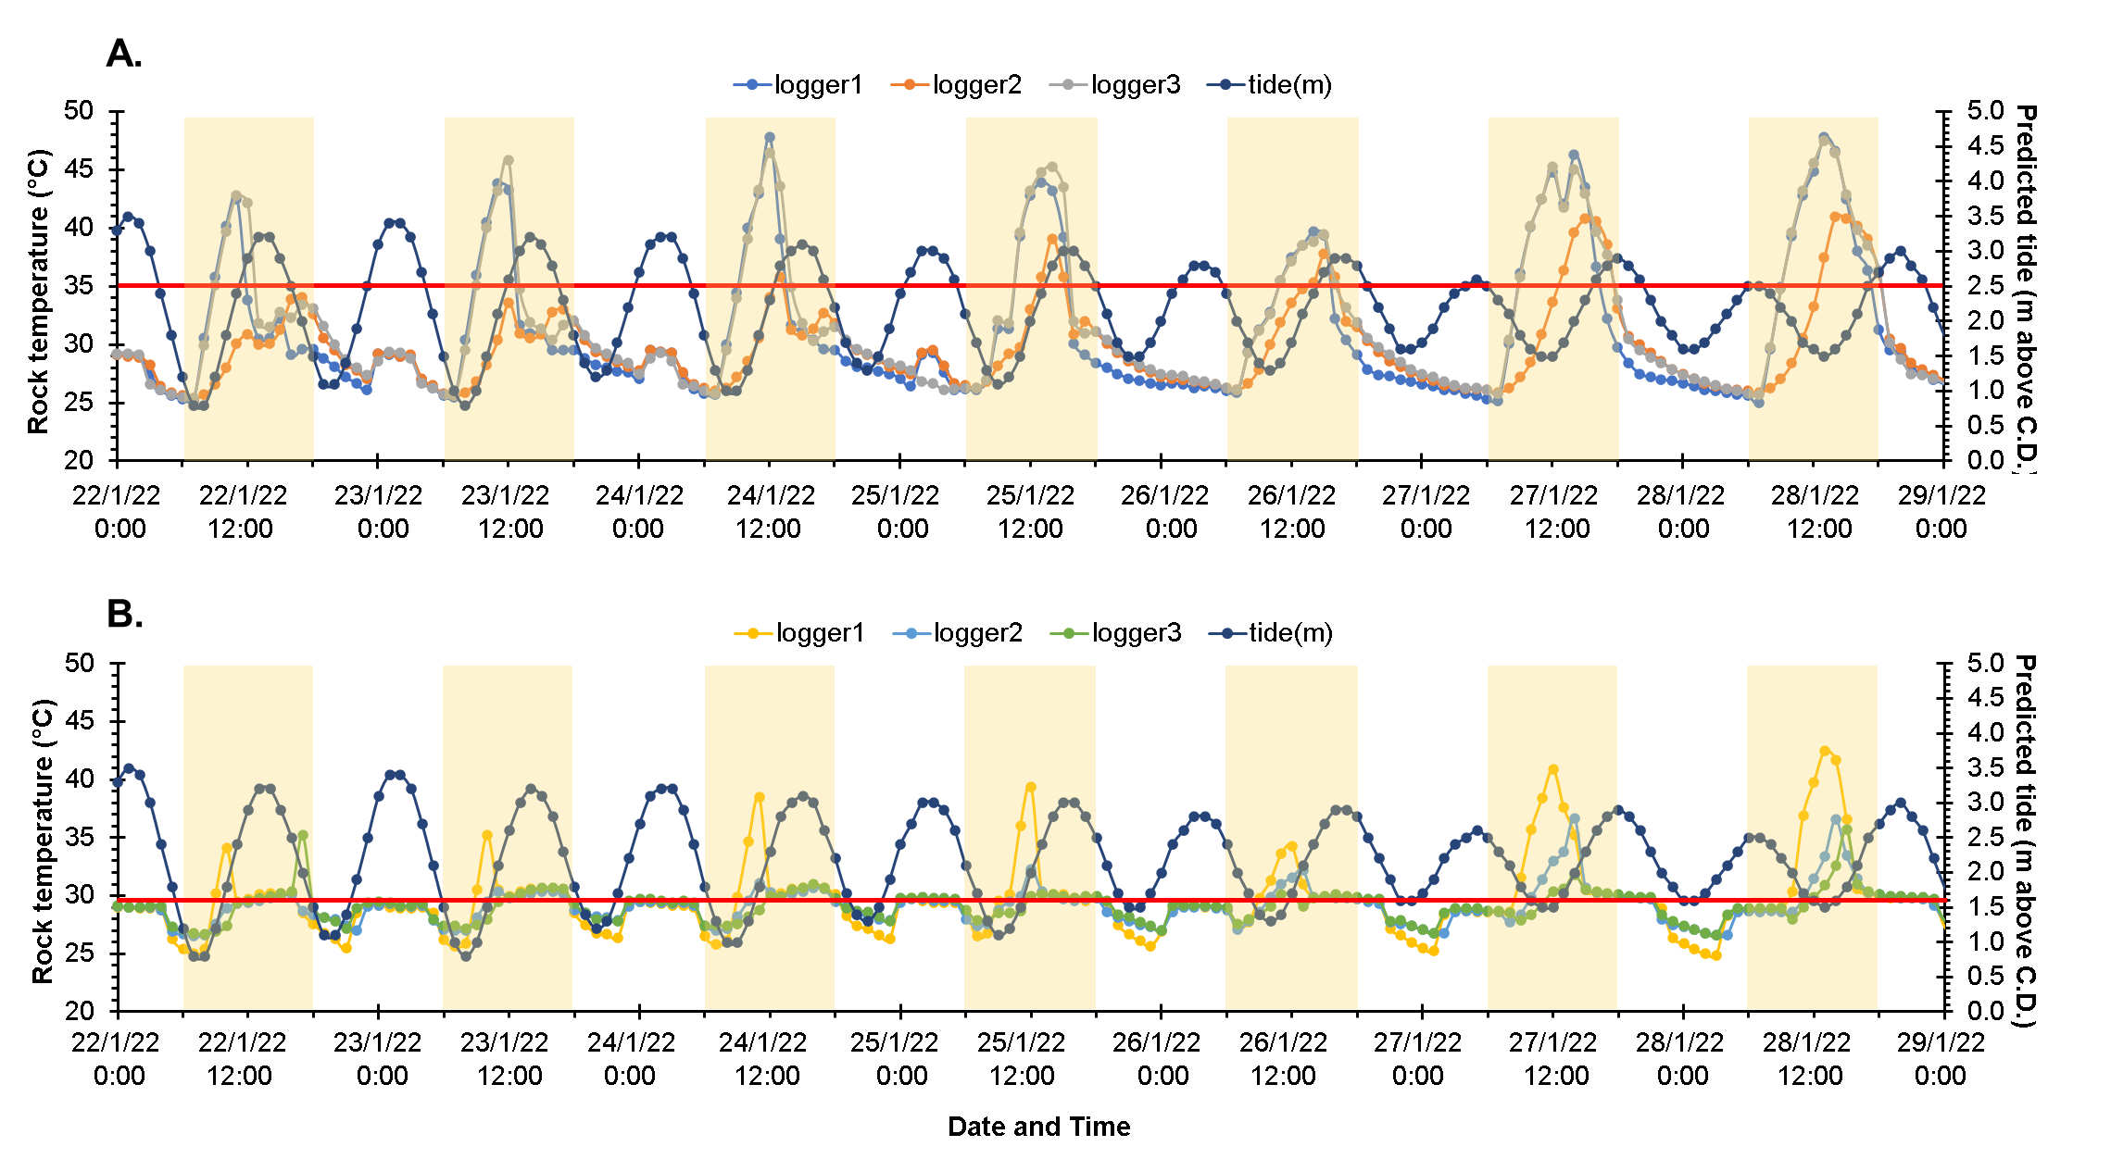
Fig. S2. Hourly temperatures recorded of Envloggers (n = 3) deployed at Phra-ae during the neap tide (22^{nd–}28th January 2022) were plotted against the predicted tide. Red lines indicate loggers’ height, which is either the most abundant level of S. guamensis (A, at 2.5 m above C.D.) or P. saccharina (B, at 1.6 m above C.D.). The yellow highlighted blocks indicate daytime periods.

