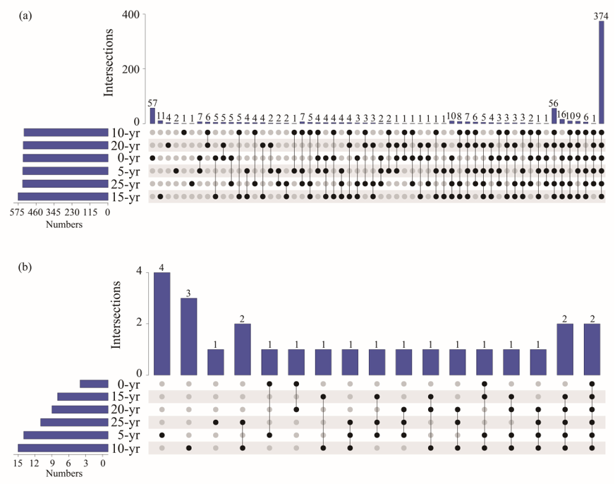
Fig. S1. Upset-plot analysis of the number of common and unique operational taxonomic unit (at the genus level) of bacteria (a) and nematodes (b).

