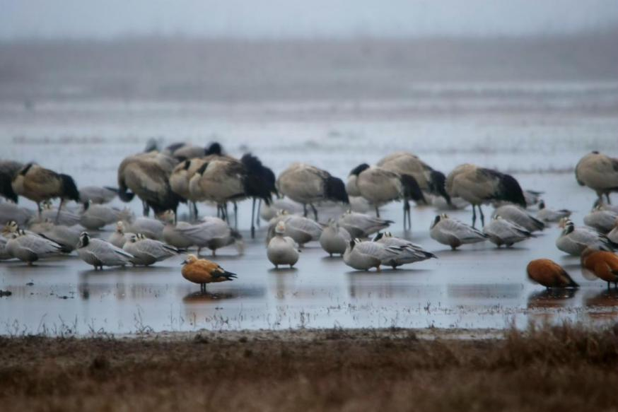
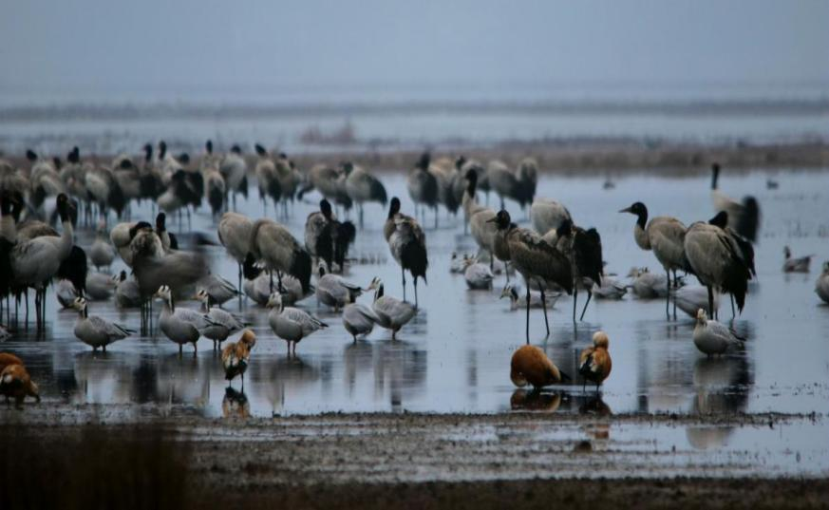
Fig. S1. Black-necked Cranes in their roosting sites in Caohai, photoed in early morning.

