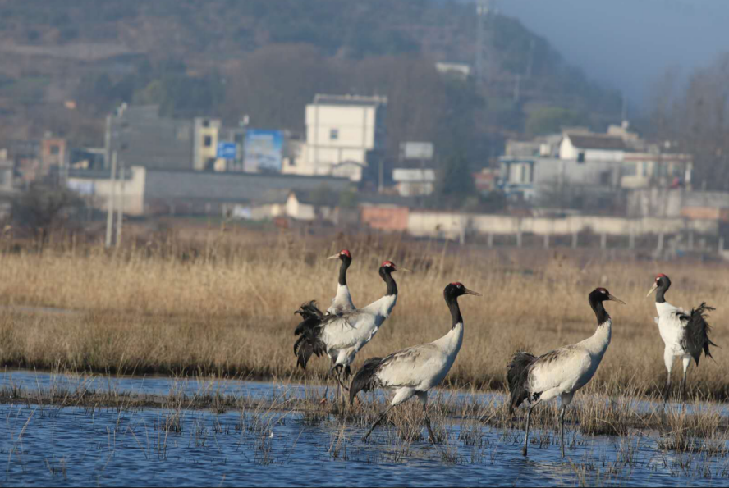

Fig. S2. Black-necked Cranes in non-roosting-site, Caohai wetland.

