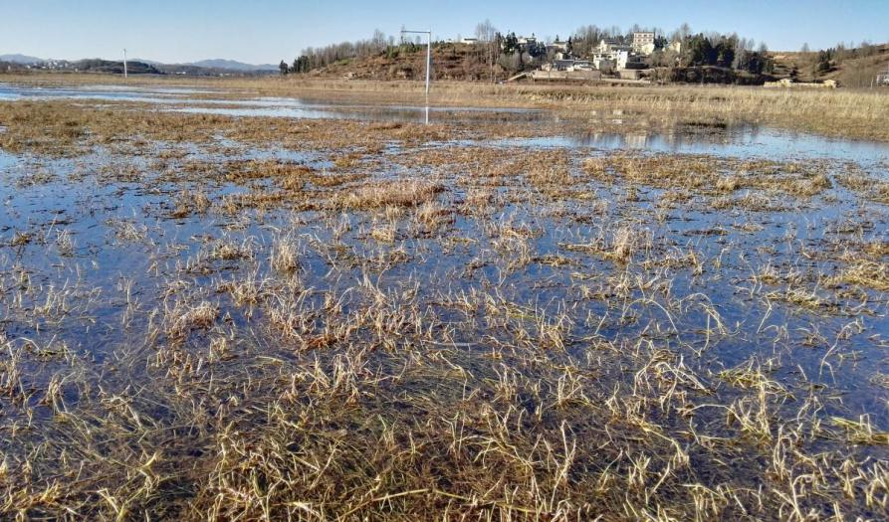

Fig. S3. Swamp near the village.

