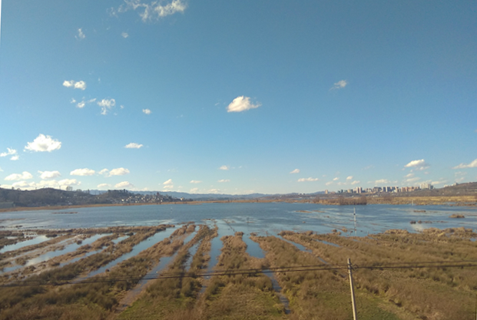
Fig. S4. View of lakeshore, the opposite is near the Weining County town, Guizhou Province, China.

