Supplemental material S1

Validation test of the UV data logger

For this work, we created a device capable of measuring all spectrums of sunlight incident on the Earth's surface. The device monitors real-time incidence of visible light, ultraviolet A and B radiation, and temperature, and is capable of recording incidence data for several months. We refer to the device here as the “UV data logger”.
For validation of the UV data logger developed by our group, the ultraviolet radiation data were compared with a commercial equipment (fix; Model: UVA MS-212A and UVB MS-212W, EKO Instruments, Japan) for five consecutive days. Subsequently, Spearman correlation tests (Zar, 1999) were performed to validate the data obtained at different accumulated doses (1, 10, 30, and 60 minutes; Table S1). The five-day average UV daily doses measured by both equipment’s are shown in Figures S1 and S2.

Table S1. Spearman correlation coefficients (rs) of comparisons between a) UVA data from the UV data logger (dt) and UVA data from the EKO (fix) data logger, and between b) UVB data from the UV data logger (dt) and UVB data from the EKO (fix) data logger. P-value < 0.01 (*).
Parameter | Dose |  | 1 min | 10 min | 30 min | 60 min
a) UVA dt × fix |  | 0.925582* | 0.940655* | 0.953560* | 0.953403*
b) UVB dt × fix |  | 0.895769* | 0.901397* | 0.912781* | 0.930501*

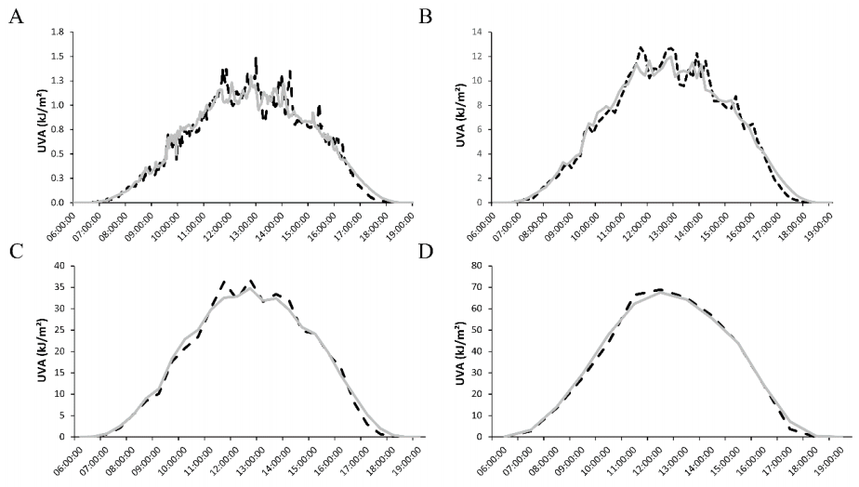
Fig. S1. Mean of five-day cumulative dose of ultraviolet A radiation (kJ/m²), recorded by dt (dotted line), and fix (grey solid line) with doses of 1 (A), 10 (B), 30 (C), and 60 minutes (D).

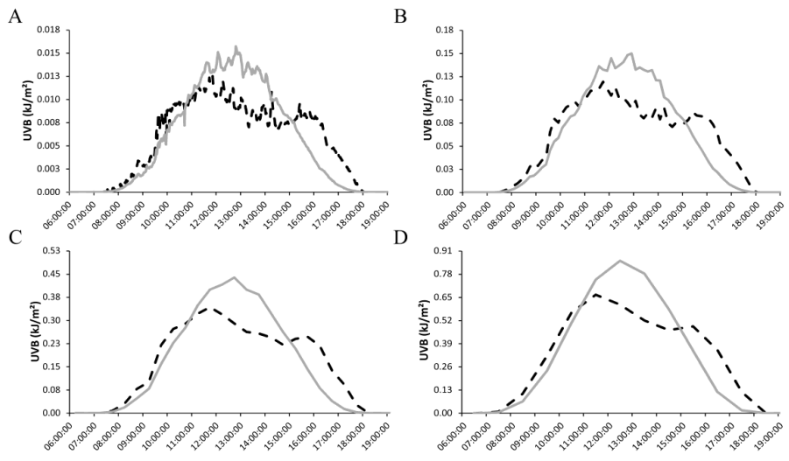
Fig. S2. Mean of five-day cumulative dose of ultraviolet B radiation (kJ/m²), recorded by dt (dotted line), and fix (grey solid line) with doses of 1 (A), 10 (B), 30 (C), and 60 minutes (D).

References

Zar, J.H. 1999. Biostatistical Analysis, 4th edition. Prentice Hall, USA.

