Supplemental material S2

Patterns of UVA and UVB incidence in control and sampling sites

We monitored the ultraviolet radiation incidence in the three fixed sampling sites and in a deforested site of the same stream, for comparison. The deforested point is called “control” and is located at the same latitude as the fixed sampling sites. Finally, we collected data from a clear sky day to describe the UV incidence in the different sites.
As expected, the mean UVB doses in a clear sky day were much higher in the control site (16.7 kJ/m², Figure S1A) than in the fixed sampling sites A (0.02 kJ/m²), B (2.69 kJ/m²), and C (0.28 kJ/m²). Likewise, the mean UVA doses were higher in the control site (1724.57 kJ/m², Figure S1B) than in the sites A (3.36 kJ/m²), B (104.59 kJ/m²) and C (41.31 kJ/m²). The data corroborates the expectation that lower UV incidence in the sampling points is expected, relative to the control site, for the presence of the canopy cover acts as a barrier against UV radiation (Lipinski et al., 2016; Rocha et al., 2020).

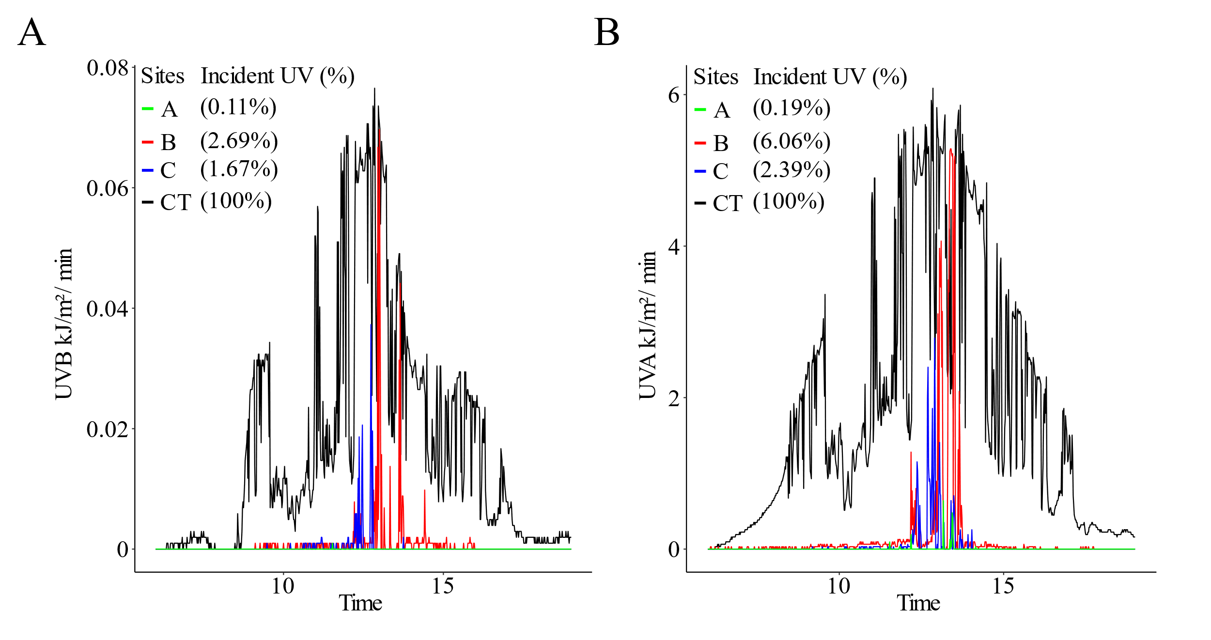
Fig. S1. Variation in the daily doses (07:00 to 18:00) of UVB and UVA (Figure A and B, respectively) in the fixed sampling sites (A to C lines in graphs) and in the control site (CT line) The daily doses for each site were: site A, UVB = 0.02 kJ/m² and UVA = 3.36 kJ/m²; site B, UVB = 0.45 kJ/m² and UVA = 104.59 kJ/m²; site C, UVB = 0.28 kJ/m² and UVA = 41,31 kJ/m²; CT, UVB = 16.7 kJ/m² and UVA = 1724,57 kJ/m². The percentages of UV dose/min in each fixed sampling sites relative to the same dose in the control site (CT) are given in parentheses inside the graphs.

References

Lipinski, V. M., Santos, T. G. dos, & Schuch, A. P. (2016). An UV-sensitive anuran species as an indicator of environmental quality of the Southern Atlantic Rainforest. Journal of Photochemistry and Photobiology B: Biology, 165, 174–181. https://doi.org/10.1016/j.jphotobiol.2016.10.025
Rocha, M. C. da, Beux, M., Zanella, R., Damian, O., Senra, A., & Passaglia, A. (2020). Preserved riparian forest protects endangered forest-specialists amphibian species against the genotoxic impact of sunlight and agrochemicals. Biological Conservation, 249(April), 108746.

