Supplemental material S4

Results and diagnostics of models following the four-step statistical analysis procedure for the dependent variable ‘Occurrence of calling behavior’

Four-step model selection — Check the complete code in the .rmd file

Step 1: Fit the Global Model (establish a baseline model that captures the relationship between the response variable and the predictor variables).

Step 2: Bootstrap Re-sampling for the Global Model (assess the stability and variability of the global model).

Step 3: Model Dredging on Global Model from Step 1 (helps identify potential alternative models that may better explain the variability in the data).

Step 4: Model Averaging (provides a consolidated estimate by combining models with AIC<2 obtained in Step 3, while takes into account the uncertainty associated with model selection by assigning weights to each model’s predictions and combining them into a final estimate).

1. Step 1: Fit the Global Model (establish a baseline model that captures the relationship between the response variable and the predictor variables).
…
# Define the function to fit the global model
fit_global_model <- function(dados718all) {
glmmTMB(res_0_1 ~ scale(uva15) * scale(cob) + scale(uvb15) * scale(cob) +
scale(uvaac) + scale(uvbac) +
scale(mean_lum) * scale(cob) + scale(mean_airt) * scale(cob) +
(1|site) + (1|date) + ar1(time+0|date), #ar1(time+0|date) allows the model to account for the fact that observations close in time within the same date group may be more correlated than observations further apart in time or in different date groups.
data = dados718all, family = binomial(cloglog))
}

# Fit the global model
occall.global_model <- fit_global_model(dados718all)
diagnose(occall.global_model)
## model looks OK!
check_convergence(occall.global_model) #no model convergence issues
## [1] TRUE
check_singularity(occall.global_model) #no model singularity issues
## [1] TRUE
occall.global_model$sdr$pdHess #the Hessian (curvature) of the model is OK
## [1] TRUE
# Display summary of the global model
summary(occall.global_model)
## Family: binomial ( cloglog )
## Formula:
## res_0_1 ~ scale(uva15) * scale(cob) + scale(uvb15) * scale(cob) +
## scale(uvaac) + scale(uvbac) + scale(mean_lum) * scale(cob) +
## scale(mean_airt) * scale(cob) + (1 | site) + (1 | date) +
## ar1(time + 0 | date)
## Data: dados718all
##
## AIC BIC logLik -2*log(L) df.resid
## 2241.0 2330.1 -1104.5 2209.0 1920
##
## Random effects:
##
## Conditional model:
## Groups Name Variance Std.Dev. Corr
## site (Intercept) 0.1367 0.3698
## date (Intercept) 0.4399 0.6633
## date.1 time10a 0.4452 0.6672 0.87 (ar1)
## Number of obs: 1936, groups: site, 3; date, 19
##
## Conditional model:
## Estimate Std. Error z value Pr(>|z|)
## (Intercept) -0.77928 0.27830 -2.800 0.00511 **
## scale(uva15) 0.02134 0.06108 0.349 0.72683
## scale(cob) -0.04912 0.04950 -0.992 0.32101
## scale(uvb15) 0.13345 0.05833 2.288 0.02215 *
## scale(uvaac) -0.05721 0.08726 -0.656 0.51210
## scale(uvbac) -0.25831 0.08824 -2.927 0.00342 **
## scale(mean_lum) -0.02040 0.07729 -0.264 0.79183
## scale(mean_airt) -0.21157 0.06906 -3.063 0.00219 **
## scale(uva15):scale(cob) 0.03973 0.09654 0.412 0.68065
## scale(cob):scale(uvb15) 0.07500 0.09916 0.756 0.44946
## scale(cob):scale(mean_lum) -0.10004 0.05313 -1.883 0.05970 .
## scale(cob):scale(mean_airt) 0.01164 0.05815 0.200 0.84133
## ---
## Signif. codes: 0 '***' 0.001 '**' 0.01 '*' 0.05 '.' 0.1 ' ' 1
# Checking collinearities from global model
occall.global_model.cln<-check_collinearity(occall.global_model, component = "conditional")
occall.global_model.cln #No VIF values >3 so there is low collinearity among all other predictors in the model
## # Check for Multicollinearity
##
## Low Correlation
##
## Term VIF VIF 95% CI adj. VIF Tolerance
## scale(uva15) 2.32 [2.17, 2.49] 1.52 0.43
## scale(cob) 1.17 [1.12, 1.24] 1.08 0.85
## scale(uvb15) 2.14 [2.00, 2.29] 1.46 0.47
## scale(uvaac) 2.05 [1.92, 2.20] 1.43 0.49
## scale(uvbac) 2.05 [1.92, 2.19] 1.43 0.49
## scale(mean_lum) 1.36 [1.29, 1.44] 1.16 0.74
## scale(mean_airt) 1.36 [1.29, 1.45] 1.17 0.73
## scale(uva15):scale(cob) 2.35 [2.20, 2.53] 1.53 0.43
## scale(cob):scale(uvb15) 2.11 [1.98, 2.26] 1.45 0.47
## scale(cob):scale(mean_lum) 1.44 [1.36, 1.53] 1.20 0.69
## scale(cob):scale(mean_airt) 1.27 [1.21, 1.34] 1.13 0.79
## Tolerance 95% CI
## [0.40, 0.46]
## [0.81, 0.89]
## [0.44, 0.50]
## [0.46, 0.52]
## [0.46, 0.52]
## [0.69, 0.78]
## [0.69, 0.77]
## [0.40, 0.46]
## [0.44, 0.51]
## [0.65, 0.73]
## [0.74, 0.83]
# Compute confidence intervals for parameters in the fitted global model
confint(occall.global_model, c(1,2,3,4,5,6,7,8,9,10),level = 0.95)
## 2.5 % 97.5 % Estimate
## (Intercept) -1.32473973 -0.23382431 -0.77928202
## scale(uva15) -0.09837372 0.14104947 0.02133788
## scale(cob) -0.14613297 0.04789225 -0.04912036
## scale(uvb15) 0.01911760 0.24777336 0.13344548
## scale(uvaac) -0.22823878 0.11382474 -0.05720702
## scale(uvbac) -0.43126301 -0.08535577 -0.25830939
## scale(mean_lum) -0.17187537 0.13107866 -0.02039836
## scale(mean_airt) -0.34693265 -0.07620566 -0.21156916
## scale(uva15):scale(cob) -0.14947961 0.22894730 0.03973384
## scale(cob):scale(uvb15) -0.11935377 0.26934532 0.07499577
par(mfrow = c(2,2), pty = "m")
# Visualize Pearson Residuals
occall.global_model.resid = simulateResiduals(occall.global_model)
plotResiduals(occall.global_model.resid, quantreg = F) #Residuals are uniformly distributed
# Test for Overdispersion
testDispersion(occall.global_model.resid) #There is no evidence of under- or over-dispersion in the residuals
##
## DHARMa nonparametric dispersion test via sd of residuals fitted vs.
## simulated
##
## data: simulationOutput
## dispersion = 0.99893, p-value = 0.776
## alternative hypothesis: two.sided
# Test for Zero-inflation
testZeroInflation(occall.global_model.resid) #There is no evidence of zero-inflation
##
## DHARMa zero-inflation test via comparison to expected zeros with
## simulation under H0 = fitted model
##
## data: simulationOutput
## ratioObsSim = 1.047, p-value = 0.688
## alternative hypothesis: two.sided
# Test for Outilers
testOutliers(occall.global_model.resid) #There is no evidence of outliers
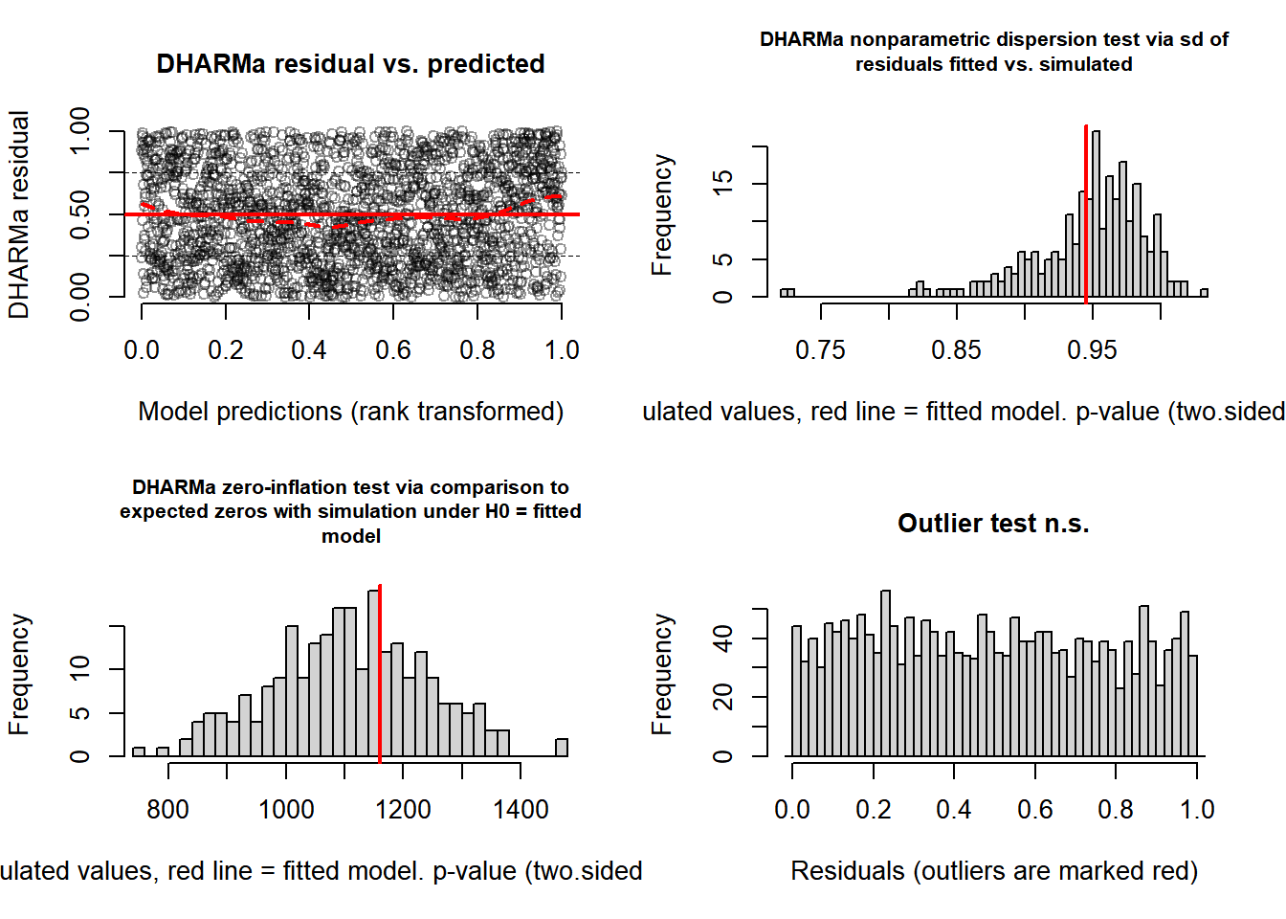
##
## DHARMa outlier test based on exact binomial test with approximate
## expectations
##
## data: occall.global_model.resid
## outliers at both margin(s) = 23, observations = 1936, p-value = 0.07114
## alternative hypothesis: true probability of success is not equal to 0.007968127
## 95 percent confidence interval:
## 0.007545501 0.017773041
## sample estimates:
## frequency of outliers (expected: 0.00796812749003984 )
## 0.01188017

2. Step 2: Bootstrap Re-sampling for the Global Model (assess the stability and variability of the global model). Generate multiple bootstrap samples from the original data set. Refit the model to each bootstrap sample, obtaining a set of parameter estimates for each re-sampled data set.
…
# Calculate meadian and quantiles
occall.median_bootstrap <- median(occall.bootstrap_estimates)
occall.median_original <- median(occall.original_estimates)
occall.quantiles_bootstrap <- quantile(occall.bootstrap_estimates, c(0.25, 0.5, 0.75))
occall.quantiles_original <- quantile(occall.original_estimates, c(0.25, 0.5, 0.75))

Visualize the Distributions of Global Model’s Estimates and Bootstrap Samples

Note that curves and median values align closely, which suggest stability in the estimates; also, quantile ranges of original model are within quantile ranges of bootstrap estimations.
par(mfrow = c(1, 1), oma = c(1, 1, 1, 1))
occall.original_density <- density(occall.original_estimates, bw = "sj", from = -1.5, to = 1)
occall.bootstrap_density <- density(occall.bootstrap_estimates, bw = "sj", from = -1.5, to = 1)

# Kernel Density Estimation plot for original model and bootstrap estimates
plot(occall.original_density, ylim = c(0, 4), main = "Kernel Density Estimation",
xlab = "Estimate Values", col = "darkblue", lwd = 2)
# Plot KDE for bootstrap estimates
lines(occall.bootstrap_density, col = "orange", lwd = 2)
legend("topleft", legend = c("Original model estimates", "Bootstrap estimates"),
fill = c("darkblue", "orange"))
# Add vertical lines for medians and quartiles
abline(v = occall.quantiles_bootstrap, col = "orange", lty = 3, lwd = 1.5)
abline(v = occall.median_bootstrap, col = "orange", lty = 5, lwd = 1.5)
abline(v = occall.quantiles_original, col = "darkblue", lty = 3, lwd = 1.5)
abline(v = occall.median_original, col = "darkblue", lty = 5, lwd = 1.5)
# Add labels for quartiles and medians
text(occall.quantiles_bootstrap, c(0.4, 0.6, 0.4), labels = c("Q1", "Median", "Q3"), col = "orange")
text(occall.quantiles_original, c(0.1, 0.3, 0.1), labels = c("Q1", "Median", "Q3"), col = "darkblue")
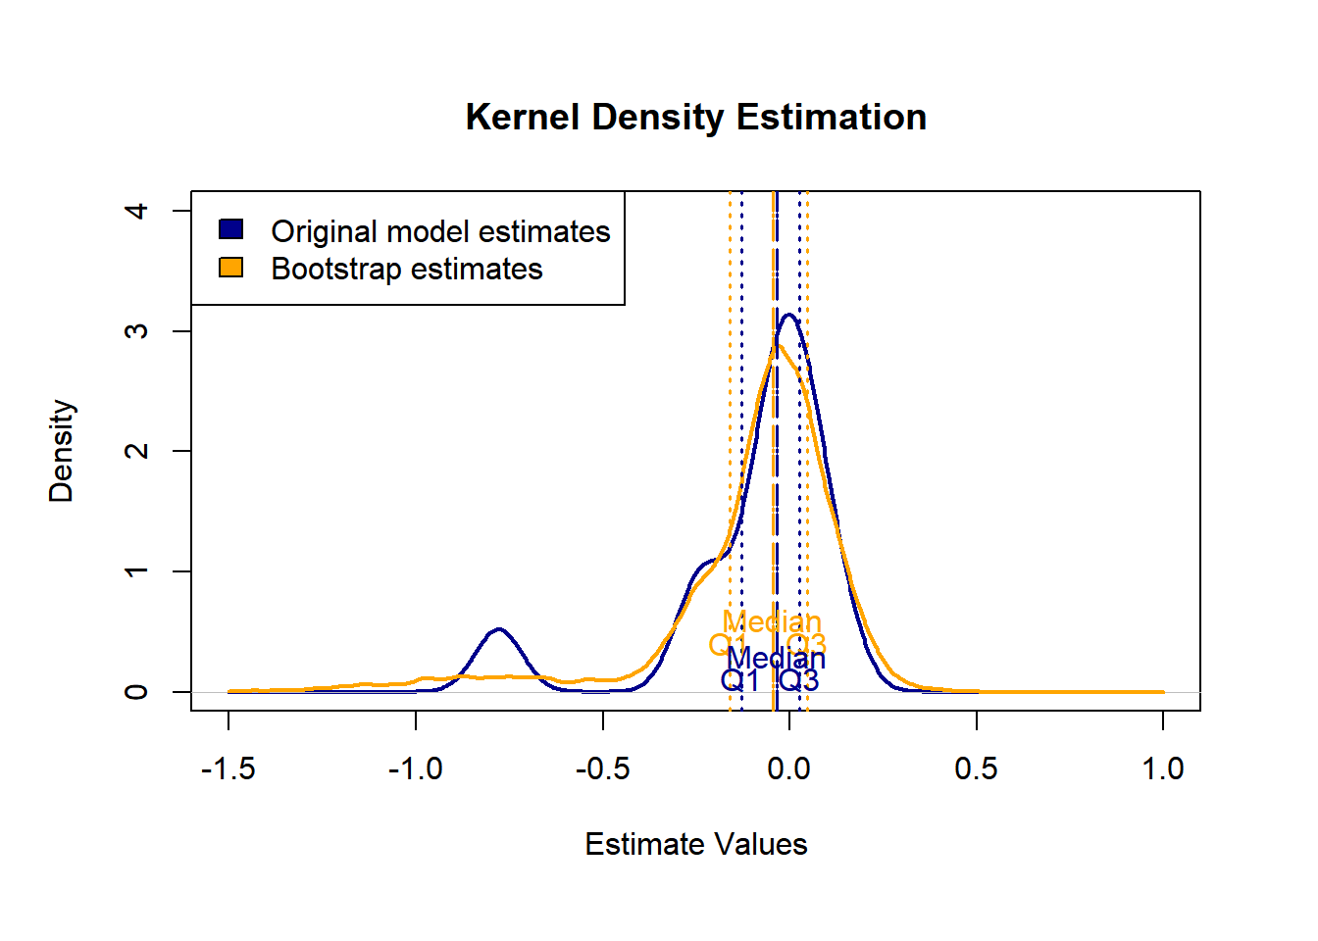

3. Step 3: Model Dredging on Global Model from Step 1 (helps identify potential alternative models that may better explain the variability in the data). In this step, we fit models using bootstrap samples and compare their AIC values to the original global model.
…
# Fit the full model
occall.global_m1 <- glmmTMB(res_0_1 ~ scale(uva15) * scale(cob) + scale(uvb15) * scale(cob) +
scale(uvaac) + scale(uvbac) +
scale(mean_lum) * scale(cob) + scale(mean_airt) * scale(cob) +
(1|site) + (1|date) + ar1(time+0|date),
data = dados718all, family = binomial(cloglog))
# Get all possible combinations of fixed effects using parallel processing
occall.dredged_model_list <- dredge(occall.global_m1, cluster = cl2, fixed = NULL)
## Fixed terms are "cond((Int))" and "disp((Int))"
# AICCtab for the best models (dAICc < 2)
AICctab(occall.selected_models, weights=T)
## dAICc df weight
## 98 0.0 8 0.52
## 114 1.5 9 0.24
## 99 1.6 9 0.24

Create a model selection table and plot it (dAICc < 2)

Note how Mean air temperature, 15 minutes cumulative UVB and Total cumulative UVB appear consistently in all models
par(mfrow = c(1, 1))
occall.model_selection_table <- model.sel(occall.selected_models)
plot(occall.model_selection_table)
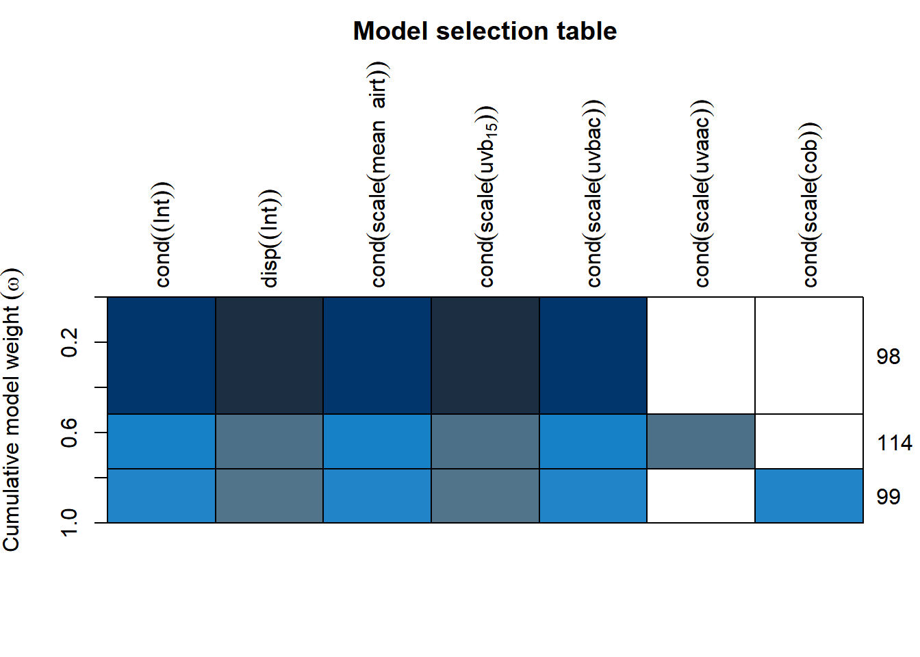

4. Step 4: Model Averaging (provides a consolidated estimate by combining models with AIC<2 obtained in Step 3). Store models that are delta AIC < 2 and average them in a final average model. Model averaging takes into account the uncertainty associated with model selection by assigning weights to each model’s predictions and combining them to obtain a final estimate.
…
# Obtain the average model from models with delta AIC < 2
occall.model.average <- model.avg(occall.dredged_model_list, subset = delta < 2, rank = "AIC", fit = TRUE)

# Display summary of the average model
summary(occall.model.average)
##
## Call:
## model.avg(object = get.models(object = occall.dredged_model_list,
## subset = delta < 2), rank = "AIC")
##
## Component model call:
## glmmTMB(formula = res_0_1 ~ <3 unique rhs>, data = dados718all, family
## = binomial(cloglog), ziformula = ~0, dispformula = ~1)
##
## Component models:
## df logLik AIC delta weight
## 245 8 -1107.14 2230.28 0.00 0.52
## 2345 9 -1106.88 2231.76 1.48 0.25
## 1245 9 -1106.91 2231.82 1.54 0.24
##
## Term codes:
## cond(scale(cob)) cond(scale(mean_airt)) cond(scale(uvaac))
## 1 2 3
## cond(scale(uvb15)) cond(scale(uvbac))
## 4 5
##
## Model-averaged coefficients:
## (full average)
## Estimate Std. Error Adjusted SE z value Pr(>|z|)
## cond((Int)) -0.778419 0.285756 0.285935 2.722 0.00648 **
## cond(scale(mean_airt)) -0.214860 0.067301 0.067343 3.191 0.00142 **
## cond(scale(uvb15)) 0.127855 0.043990 0.044018 2.905 0.00368 **
## cond(scale(uvbac)) -0.289122 0.073180 0.073223 3.948 7.86e-05 ***
## cond(scale(uvaac)) -0.015178 0.050349 0.050372 0.301 0.76317
## cond(scale(cob)) -0.007349 0.025927 0.025939 0.283 0.77693
##
## (conditional average)
## Estimate Std. Error Adjusted SE z value Pr(>|z|)
## cond((Int)) -0.77842 0.28576 0.28594 2.722 0.00648 **
## cond(scale(mean_airt)) -0.21486 0.06730 0.06734 3.191 0.00142 **
## cond(scale(uvb15)) 0.12786 0.04399 0.04402 2.905 0.00368 **
## cond(scale(uvbac)) -0.28912 0.07318 0.07322 3.948 7.86e-05 ***
## cond(scale(uvaac)) -0.06171 0.08623 0.08628 0.715 0.47447
## cond(scale(cob)) -0.03080 0.04577 0.04580 0.672 0.50128
## ---
## Signif. codes: 0 '***' 0.001 '**' 0.01 '*' 0.05 '.' 0.1 ' ' 1
## --- Pseudo-R² (Pearson) for the best model and model-averaged predictions ---
# 1) Identify and extract the best model (ΔAIC = 0)
best_model.occall <- get.models(occall.dredged_model_list, subset = delta == 0)[[1]]

# 2) Generate predictions for the best model
pred_best.occall <- predict(best_model.occall, type = "response")

# 3) Calculate pseudo-R² (Pearson) for the best model
R2_pseudo_best.occall <- cor(pred_best.occall, dados718all$res_0_1)^2

# 4) Generate model-averaged predictions (weighted average across models ΔAIC < 2)
pred_avg.occall <- predict(occall.model.average, type = "response")

# 5) Calculate pseudo-R² (Pearson) for the averaged model
R2_pseudo_avg.occall <- cor(pred_avg.occall, dados718all$res_0_1)^2

# 6) Display results
cat("\n------ Pseudo-R² (Pearson) ------\n")
##
## ------ Pseudo-R² (Pearson) ------
cat("Best model (ΔAIC = 0): ", round(R2_pseudo_best.occall, 3), "\n")
## Best model (ΔAIC = 0): 0.348
cat("Averaged model (ΔAIC < 2): ", round(R2_pseudo_avg.occall, 3), "\n")
## Averaged model (ΔAIC < 2): 0.347
cat("---------------------------------\n")
## ---------------------------------

5. Step 5: Fitting a Null Model and Comparing It with the Candidate Models

Objective: Fit a null model containing only random effects and temporal autocorrelation, and include it in the candidate model set to compare its AICc, ΔAICc, degrees of freedom, and Akaike weight against the best-supported models.
…
# Fit the null model
# Define the function to fit the null model
fit_null_model_occall <- function(dados718all) {
glmmTMB(
res_0_1 ~ 1 +
(1 | site) +
(1 | date) +
ar1(time + 0 | date),
data = dados718all,
family = binomial(cloglog)
)
}

# Fit the null model
occall.null_model <- fit_null_model_occall(dados718all)

# Diagnostics
diagnose(occall.null_model)
## Unusually large Z-statistics (|x|>5):
##
## theta_time+0|date.2
## 5.422047
##
## Large Z-statistics (estimate/std err) suggest a *possible* failure of
## the Wald approximation - often also associated with parameters that are
## at or near the edge of their range (e.g. random-effects standard
## deviations approaching 0). (Alternately, they may simply represent
## very well-estimated parameters; intercepts of non-centered models may
## fall in this category.) While the Wald p-values and standard errors
## listed in summary() may be unreliable, profile confidence intervals
## (see ?confint.glmmTMB) and likelihood ratio test p-values derived by
## comparing models (e.g. ?drop1) are probably still OK. (Note that the
## LRT is conservative when the null value is on the boundary, e.g. a
## variance or zero-inflation value of 0 (Self and Liang 1987; Stram and
## Lee 1994; Goldman and Whelan 2000); in simple cases these p-values are
## approximately twice as large as they should be.)
check_convergence(occall.null_model)
## [1] TRUE
check_singularity(occall.null_model)
## [1] TRUE
occall.null_model$sdr$pdHess
## [1] TRUE
# Summary
summary(occall.null_model)
## Family: binomial ( cloglog )
## Formula: res_0_1 ~ 1 + (1 | site) + (1 | date) + ar1(time + 0 | date)
## Data: dados718all
##
## AIC BIC logLik -2*log(L) df.resid
## 2266.8 2294.7 -1128.4 2256.8 1931
##
## Random effects:
##
## Conditional model:
## Groups Name Variance Std.Dev. Corr
## site (Intercept) 0.1977 0.4446
## date (Intercept) 0.3905 0.6249
## date.1 time10a 0.6015 0.7756 0.88 (ar1)
## Number of obs: 1936, groups: site, 3; date, 19
##
## Conditional model:
## Estimate Std. Error z value Pr(>|z|)
## (Intercept) -0.7082 0.3123 -2.268 0.0234 *
## ---
## Signif. codes: 0 '***' 0.001 '**' 0.01 '*' 0.05 '.' 0.1 ' ' 1
#Extract degrees of freedom (number of parameters)
# Degrees of freedom (K)
df_null.occall <- attr(logLik(occall.null_model), "df")
df_null.occall
## [1] 5
#Include the Full and the Null models in the candidate model set
# Combine null and full models with the selected models (ΔAICc < 2)
occall.models.with.null.full <- c(
list(null = occall.null_model, full = occall.global_m1),
occall.selected_models
)

# AICc table incluindo o modelo nulo
occall.AICc.table <- AICctab(occall.models.with.null.full, weights = TRUE, base=TRUE)

model_summaries.occall <- lapply(occall.models.with.null.full, summary)
model_summaries.occall[["null"]]
## Family: binomial ( cloglog )
## Formula: res_0_1 ~ 1 + (1 | site) + (1 | date) + ar1(time + 0 | date)
## Data: dados718all
##
## AIC BIC logLik -2*log(L) df.resid
## 2266.8 2294.7 -1128.4 2256.8 1931
##
## Random effects:
##
## Conditional model:
## Groups Name Variance Std.Dev. Corr
## site (Intercept) 0.1977 0.4446
## date (Intercept) 0.3905 0.6249
## date.1 time10a 0.6015 0.7756 0.88 (ar1)
## Number of obs: 1936, groups: site, 3; date, 19
##
## Conditional model:
## Estimate Std. Error z value Pr(>|z|)
## (Intercept) -0.7082 0.3123 -2.268 0.0234 *
## ---
## Signif. codes: 0 '***' 0.001 '**' 0.01 '*' 0.05 '.' 0.1 ' ' 1
model_summaries.occall[["98"]]
## Family: binomial ( cloglog )
## Formula:
## res_0_1 ~ scale(mean_airt) + scale(uvb15) + scale(uvbac) + (1 |
## site) + (1 | date) + (ar1(time + 0 | date))
## Data: dados718all
##
## AIC BIC logLik -2*log(L) df.resid
## 2230.3 2274.8 -1107.1 2214.3 1928
##
## Random effects:
##
## Conditional model:
## Groups Name Variance Std.Dev. Corr
## site (Intercept) 0.1511 0.3887
## date (Intercept) 0.4501 0.6709
## date.1 time10a 0.4585 0.6771 0.87 (ar1)
## Number of obs: 1936, groups: site, 3; date, 19
##
## Conditional model:
## Estimate Std. Error z value Pr(>|z|)
## (Intercept) -0.77781 0.28768 -2.704 0.00686 **
## scale(mean_airt) -0.21612 0.06716 -3.218 0.00129 **
## scale(uvb15) 0.12815 0.04400 2.913 0.00358 **
## scale(uvbac) -0.29978 0.06448 -4.649 3.33e-06 ***
## ---
## Signif. codes: 0 '***' 0.001 '**' 0.01 '*' 0.05 '.' 0.1 ' ' 1
model_formulas.occall <- lapply(occall.models.with.null.full, formula)
model_formulas.occall[["null"]]
## res_0_1 ~ 1 + (1 | site) + (1 | date) + ar1(time + 0 | date)
## <environment: 0x00000203e81700a8>
model_formulas.occall[["98"]]
## res_0_1 ~ scale(mean_airt) + scale(uvb15) + scale(uvbac) + (1 |
## site) + (1 | date) + (ar1(time + 0 | date))
model_ids.occall <- intersect(
rownames(occall.AICc.table),
names(occall.models.with.null.full)
)

model_formulas.occall <- sapply(
occall.models.with.null.full[model_ids.occall],
function(m) paste(deparse(formula(m)), collapse = " ")
)

model_formulas.occall
## named list()
AICctab(occall.models.with.null.full, weights = TRUE, base=TRUE)
## AICc dAICc df weight
## 98 2230.4 0.0 8 0.5167
## 114 2231.9 1.5 9 0.2443
## 99 2231.9 1.6 9 0.2370
## full 2241.3 11.0 16 0.0021
## null 2266.9 36.5 5 <0.001
### The forest plot of the "Full Average" effect sizes of the Average Model. The full average includes all models in the set, regardless of their weights or AIC differences. It provides a weighted average of parameter estimates across all models, considering each model's weight in the averaging process. Use it when interested in an overall estimate that considers the uncertainty associated with model selection.
### See that the effects of Mean air temperature (mean_airt), 15 minutes cumulative UVB (uvb15) and Total cumulative UVB (uvbac) do not overlap zero.
# Display summary of the average model
summary(occall.model.average)
##
## Call:
## model.avg(object = get.models(object = occall.dredged_model_list,
## subset = delta < 2), rank = "AIC")
##
## Component model call:
## glmmTMB(formula = res_0_1 ~ <3 unique rhs>, data = dados718all, family
## = binomial(cloglog), ziformula = ~0, dispformula = ~1)
##
## Component models:
## df logLik AIC delta weight
## 245 8 -1107.14 2230.28 0.00 0.52
## 2345 9 -1106.88 2231.76 1.48 0.25
## 1245 9 -1106.91 2231.82 1.54 0.24
##
## Term codes:
## cond(scale(cob)) cond(scale(mean_airt)) cond(scale(uvaac))
## 1 2 3
## cond(scale(uvb15)) cond(scale(uvbac))
## 4 5
##
## Model-averaged coefficients:
## (full average)
## Estimate Std. Error Adjusted SE z value Pr(>|z|)
## cond((Int)) -0.778419 0.285756 0.285935 2.722 0.00648 **
## cond(scale(mean_airt)) -0.214860 0.067301 0.067343 3.191 0.00142 **
## cond(scale(uvb15)) 0.127855 0.043990 0.044018 2.905 0.00368 **
## cond(scale(uvbac)) -0.289122 0.073180 0.073223 3.948 7.86e-05 ***
## cond(scale(uvaac)) -0.015178 0.050349 0.050372 0.301 0.76317
## cond(scale(cob)) -0.007349 0.025927 0.025939 0.283 0.77693
##
## (conditional average)
## Estimate Std. Error Adjusted SE z value Pr(>|z|)
## cond((Int)) -0.77842 0.28576 0.28594 2.722 0.00648 **
## cond(scale(mean_airt)) -0.21486 0.06730 0.06734 3.191 0.00142 **
## cond(scale(uvb15)) 0.12786 0.04399 0.04402 2.905 0.00368 **
## cond(scale(uvbac)) -0.28912 0.07318 0.07322 3.948 7.86e-05 ***
## cond(scale(uvaac)) -0.06171 0.08623 0.08628 0.715 0.47447
## cond(scale(cob)) -0.03080 0.04577 0.04580 0.672 0.50128
## ---
## Signif. codes: 0 '***' 0.001 '**' 0.01 '*' 0.05 '.' 0.1 ' ' 1
# Compute confidence intervals for parameters in the fitted average model
confint(occall.model.average,level = 0.95)
## 2.5 % 97.5 %
## cond((Int)) -1.33884152 -0.21799580
## cond(scale(mean_airt)) -0.34685116 -0.08286961
## cond(scale(uvb15)) 0.04158231 0.21412817
## cond(scale(uvbac)) -0.43263786 -0.14560705
## cond(scale(uvaac)) -0.23081961 0.10739876
## cond(scale(cob)) -0.12056394 0.05896649
common_theme <- set_theme(base = theme_bw(),
panel.major.gridcol = FALSE,
panel.minor.gridcol = FALSE,
axis.title.size = 1.1, axis.title.color = "black", axis.title.y.vjust = 3,
axis.textcolor = "black",
plot.margin = margin(0.2, 0.5, 0.5, 0.2, "cm"))

plot1_occall <- plot_models(occall.model.average, title = "",
grid = FALSE, dot.size = 2, spacing = 0.6, show.p = TRUE, p.shape = FALSE,
transform = NULL, ci.lvl = 0.95, line.size = 1, show.legend = FALSE,
vline.color = "grey", axis.lim = c(), colors = "bw",
axis.labels = c()) +
common_theme
plot1_occall
