Supplemental material S6

Results and diagnostics of models following the four-step statistical analysis procedure for the dependent variable ‘Mean duration of calls’

Four-step model selection — Check the complete code in the .rmd file

Step 1: Fit the Global Model (establish a baseline model that captures the relationship between the response variable and the predictor variables).

Step 2: Bootstrap Re-sampling for the Global Model (assess the stability and variability of the global model).

Step 3: Model Dredging on Global Model from Step 1 (helps identify potential alternative models that may better explain the variability in the data).

Step 4: Model Averaging (provides a consolidated estimate by combining models with AIC<2 obtained in Step 3, while takes into account the uncertainty associated with model selection by assigning weights to each model’s predictions and combining them into a final estimate).

1. Step 1: Fit the Global Model (establish a baseline model that captures the relationship between the response variable and the predictor variables).
…
# Define the function to fit the global model
fit_global_model_durcall <- function(dados718active) {
glmmTMB(call_dur_mean ~ scale(uva15) * scale(cob) + scale(uvb15) * scale(cob) +
scale(uvaac) + scale(uvbac) +
scale(mean_lum) * scale(cob) + scale(mean_airt) * scale(cob) +
(1|site) + (1|date) + ar1(time+0|date), #ar1(time+0|date) allows the model to account for the fact that observations close in time within the same date group may be more correlated than observations further apart in time or in different date groups.
data = dados718active, family = gaussian(identity))
}

# Fit the global model
durcall.global_model <- fit_global_model_durcall(dados718active)
diagnose(durcall.global_model)
## Unusually large Z-statistics (|x|>5):
##
## (Intercept) disp~(Intercept) theta_time+0|date.1
## 12.279104 -6.179516 -5.142674
##
## Large Z-statistics (estimate/std err) suggest a *possible* failure of
## the Wald approximation - often also associated with parameters that are
## at or near the edge of their range (e.g. random-effects standard
## deviations approaching 0). (Alternately, they may simply represent
## very well-estimated parameters; intercepts of non-centered models may
## fall in this category.) While the Wald p-values and standard errors
## listed in summary() may be unreliable, profile confidence intervals
## (see ?confint.glmmTMB) and likelihood ratio test p-values derived by
## comparing models (e.g. ?drop1) are probably still OK. (Note that the
## LRT is conservative when the null value is on the boundary, e.g. a
## variance or zero-inflation value of 0 (Self and Liang 1987; Stram and
## Lee 1994; Goldman and Whelan 2000); in simple cases these p-values are
## approximately twice as large as they should be.)
check_convergence(durcall.global_model) #no model convergence issues
## [1] TRUE
check_singularity(durcall.global_model) #no model singularity issues
## [1] TRUE
durcall.global_model$sdr$pdHess #the Hessian (curvature) of the model is OK
## [1] TRUE
# Display summary of the global model
summary(durcall.global_model)
## Family: gaussian ( identity )
## Formula:
## call_dur_mean ~ scale(uva15) * scale(cob) + scale(uvb15) * scale(cob) +
## scale(uvaac) + scale(uvbac) + scale(mean_lum) * scale(cob) +
## scale(mean_airt) * scale(cob) + (1 | site) + (1 | date) +
## ar1(time + 0 | date)
## Data: dados718active
##
## AIC BIC logLik -2*log(L) df.resid
## 2102.3 2181.4 -1034.2 2068.3 758
##
## Random effects:
##
## Conditional model:
## Groups Name Variance Std.Dev. Corr
## site (Intercept) 0.23447 0.4842
## date (Intercept) 0.06097 0.2469
## date.1 time10a 0.21619 0.4650 0.88 (ar1)
## Residual 0.69028 0.8308
## Number of obs: 775, groups: site, 3; date, 19
##
## Dispersion estimate for gaussian family (sigma^2): 0.69
##
## Conditional model:
## Estimate Std. Error z value Pr(>|z|)
## (Intercept) 3.605875 0.293659 12.279 <2e-16 ***
## scale(uva15) 0.069328 0.054452 1.273 0.2030
## scale(cob) -0.047232 0.035619 -1.326 0.1848
## scale(uvb15) -0.041740 0.050123 -0.833 0.4050
## scale(uvaac) 0.005964 0.061156 0.098 0.9223
## scale(uvbac) 0.109518 0.063027 1.738 0.0823 .
## scale(mean_lum) -0.045318 0.065257 -0.694 0.4874
## scale(mean_airt) -0.147426 0.052029 -2.834 0.0046 **
## scale(uva15):scale(cob) 0.010893 0.082609 0.132 0.8951
## scale(cob):scale(uvb15) 0.011503 0.078870 0.146 0.8840
## scale(cob):scale(mean_lum) -0.011487 0.042951 -0.267 0.7891
## scale(cob):scale(mean_airt) -0.051465 0.043534 -1.182 0.2371
## ---
## Signif. codes: 0 '***' 0.001 '**' 0.01 '*' 0.05 '.' 0.1 ' ' 1
# Checking collinearities from global model
durcall.global_model.cln<-check_collinearity(durcall.global_model, component = "conditional")
durcall.global_model.cln #No VIF values >3 so there is low collinearity among all other predictors in the model

Term  <chr> | VIF  <dbl> | VIF_CI_low  <dbl> | VIF_CI_high  <dbl> | SE_factor  <dbl> | Tolerance  <dbl> | Tolerance_CI_low  <dbl>
scale(uva15) | 2.466004 | 2.218325 | 2.764035 | 1.570352 | 0.4055143 | 0.3617899
scale(cob) | 1.126772 | 1.064079 | 1.250802 | 1.061495 | 0.8874911 | 0.7994873
scale(uvb15) | 2.134024 | 1.929536 | 2.383497 | 1.460830 | 0.4685983 | 0.4195516
scale(uvaac) | 1.575101 | 1.444332 | 1.744357 | 1.255030 | 0.6348798 | 0.5732772
scale(uvbac) | 1.630834 | 1.492585 | 1.807883 | 1.277041 | 0.6131832 | 0.5531331
scale(mean_lum) | 1.313277 | 1.218949 | 1.448242 | 1.145983 | 0.7614541 | 0.6904923
scale(mean_airt) | 1.386526 | 1.281657 | 1.530440 | 1.177508 | 0.7212270 | 0.6534068
scale(uva15):scale(cob) | 2.875653 | 2.574870 | 3.233882 | 1.695775 | 0.3477471 | 0.3092259
scale(cob):scale(uvb15) | 2.560719 | 2.300748 | 2.872648 | 1.600225 | 0.3905154 | 0.3481108
scale(cob):scale(mean_lum) | 1.449851 | 1.336143 | 1.602022 | 1.204097 | 0.6897262 | 0.6242110
1-10 of 11 rows | 1-7 of 8 columns
# Compute confidence intervals for parameters in the fitted global model
confint(durcall.global_model, c(1,2,3,4,5,6,7,8,9,10),level = 0.95)
## 2.5 % 97.5 % Estimate
## (Intercept) 3.03031309 4.18143698 3.605875036
## scale(uva15) -0.03739657 0.17605260 0.069328015
## scale(cob) -0.11704289 0.02257941 -0.047231738
## scale(uvb15) -0.13998010 0.05649972 -0.041740189
## scale(uvaac) -0.11389933 0.12582649 0.005963579
## scale(uvbac) -0.01401321 0.23304858 0.109517684
## scale(mean_lum) -0.17321988 0.08258475 -0.045317567
## scale(mean_airt) -0.24940136 -0.04544994 -0.147425652
## scale(uva15):scale(cob) -0.15101818 0.17280446 0.010893140
## scale(cob):scale(uvb15) -0.14307896 0.16608522 0.011503132
par(mfrow = c(3,1), pty = "m")
# Visualize Pearson Residuals
durcall.global_model.resid = simulateResiduals(durcall.global_model)
plotResiduals(durcall.global_model.resid, quantreg = FALSE) #Residuals are mostly uniformly distributed
# Test for Overdispersion
testDispersion(durcall.global_model.resid) #There is no evidence of under- or over-dispersion in the residuals
##
## DHARMa nonparametric dispersion test via sd of residuals fitted vs.
## simulated
##
## data: simulationOutput
## dispersion = 1.1362, p-value = 0.32
## alternative hypothesis: two.sided
# Test for Outilers
testOutliers(durcall.global_model.resid) #There is no evidence of outliers
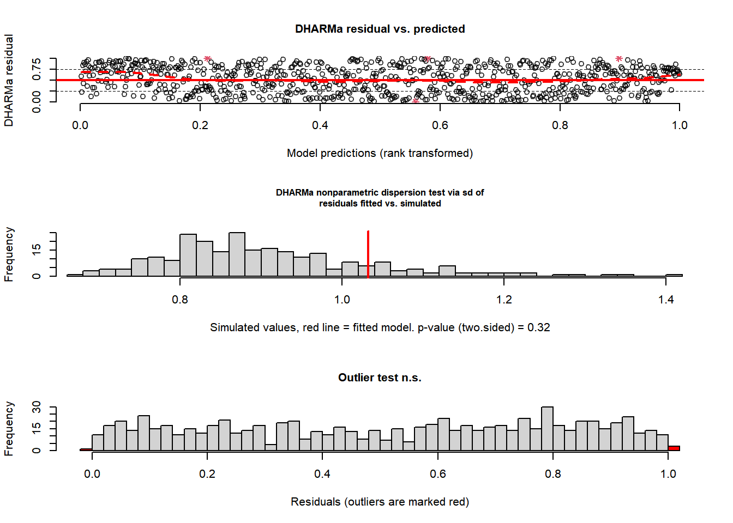
##
## DHARMa outlier test based on exact binomial test with approximate
## expectations
##
## data: durcall.global_model.resid
## outliers at both margin(s) = 4, observations = 775, p-value = 0.5412
## alternative hypothesis: true probability of success is not equal to 0.007968127
## 95 percent confidence interval:
## 0.001408015 0.013161820
## sample estimates:
## frequency of outliers (expected: 0.00796812749003984 )
## 0.00516129

2. Step 2: Bootstrap Re-sampling for the Global Model (assess the stability and variability of the global model). Generate multiple bootstrap samples from the original data set. Refit the model to each bootstrap sample, obtaining a set of parameter estimates for each re-sampled data set.
…
# Calculate meadian and quantiles
durcall.median_bootstrap <- median(durcall.bootstrap_estimates)
durcall.median_original <- median(durcall.original_estimates)
durcall.quantiles_bootstrap <- quantile(durcall.bootstrap_estimates, c(0.25, 0.5, 0.75))
durcall.quantiles_original <- quantile(durcall.original_estimates, c(0.25, 0.5, 0.75))

Visualize the Distributions of Global Model’s Estimates and Bootstrap Samples

Note that curves and median values align closely, which suggest stability in the estimates; also, quantile ranges of original model are within quantile ranges of bootstrap estimations.
par(mfrow = c(1, 1), oma = c(1, 1, 1, 1))
durcall.original_density <- density(durcall.original_estimates, bw = "sj", from = -0.5, to = 0.5)
durcall.bootstrap_density <- density(durcall.bootstrap_estimates, bw = "sj", from = -0.5, to = 0.5)

# Kernel Density Estimation plot for original model and bootstrap estimates
plot(durcall.original_density, ylim = c(0, 6.5), main = "Kernel Density Estimation",
xlab = "Estimate Values", col = "darkblue", lwd = 2)
# Plot KDE for bootstrap estimates
lines(durcall.bootstrap_density, col = "orange", lwd = 2)
legend("topright", legend = c("Original model estimates", "Bootstrap estimates"),
fill = c("darkblue", "orange"))
# Add vertical lines for medians and quartiles
abline(v = durcall.quantiles_bootstrap, col = "orange", lty = 3, lwd = 1.5)
abline(v = durcall.median_bootstrap, col = "orange", lty = 5, lwd = 1.5)
abline(v = durcall.quantiles_original, col = "darkblue", lty = 3, lwd = 1.5)
abline(v = durcall.median_original, col = "darkblue", lty = 5, lwd = 1.5)
# Add labels for quartiles and medians
text(durcall.quantiles_bootstrap, c(0.4, 0.6, 0.4), labels = c("Q1", "Median", "Q3"), col = "orange")
text(durcall.quantiles_original, c(0.1, 0.3, 0.1), labels = c("Q1", "Median", "Q3"), col = "darkblue")
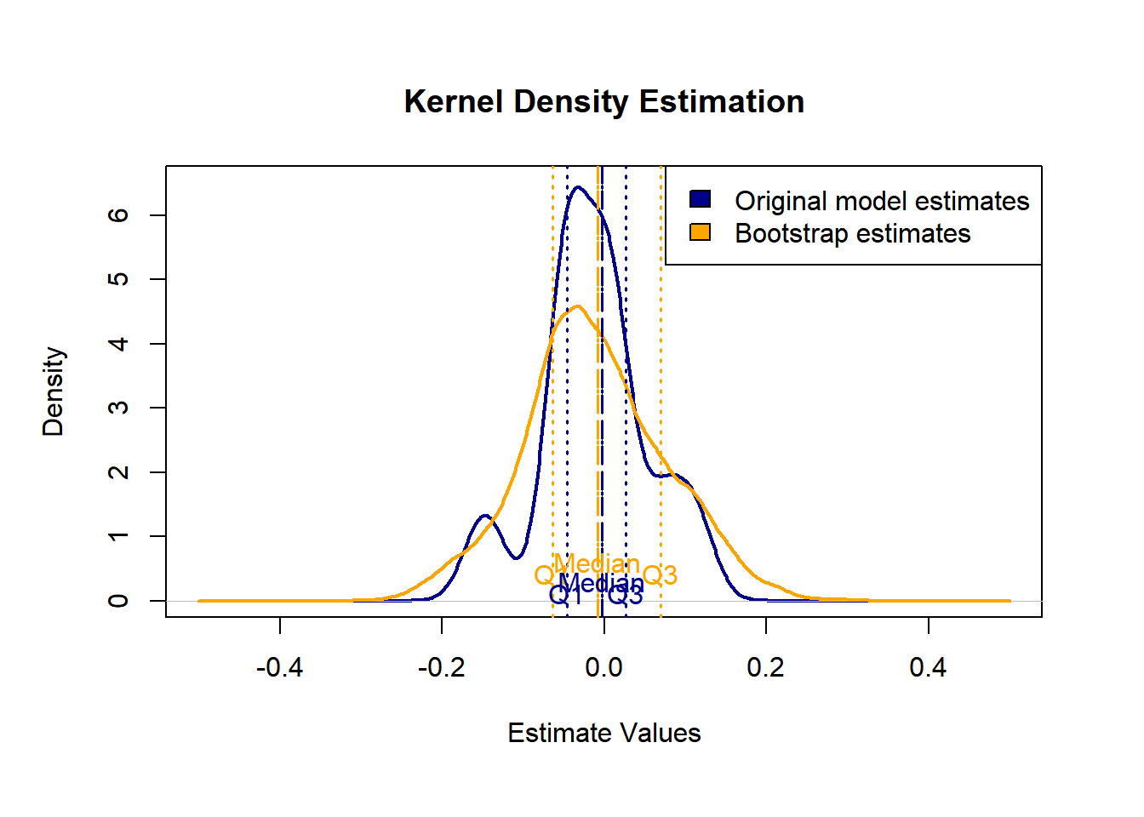

3. Step 3: Model Dredging on Global Model from Step 1 (helps identify potential alternative models that may better explain the variability in the data). In this step, we fit models using bootstrap samples and compare their AIC values to the original global model.
…
# Fit the full model
durcall.global_m1 <- glmmTMB(call_dur_mean ~ scale(uva15) * scale(cob) + scale(uvb15) * scale(cob) +
scale(uvaac) + scale(uvbac) +
scale(mean_lum) * scale(cob) + scale(mean_airt) * scale(cob) +
(1|site) + (1|date) + ar1(time+0|date),
data = dados718active, family = gaussian(identity))
# Get all possible combinations of fixed effects using parallel processing
durcall.dredged_model_list <- dredge(durcall.global_m1, cluster = cl2, fixed = NULL)
## Fixed terms are "cond((Int))" and "disp((Int))"
# AICCtab for the best models (dAICc < 2)
AICctab(durcall.selected_models, weights=T)
## dAICc df weight
## 66 0.0 8 0.211
## 67 0.7 9 0.147
## 74 1.2 9 0.118
## 195 1.2 10 0.117
## 98 1.8 9 0.086
## 106 1.9 10 0.081
## 70 1.9 9 0.081
## 75 1.9 10 0.081
## 82 2.0 9 0.079

Create a model selection table and plot it (dAICc < 2)

Note how air temperature and cumulative dose of UVB appear consistently in all models
par(mfrow = c(1, 1))
durcall.model_selection_table <- model.sel(durcall.selected_models)
plot(durcall.model_selection_table)
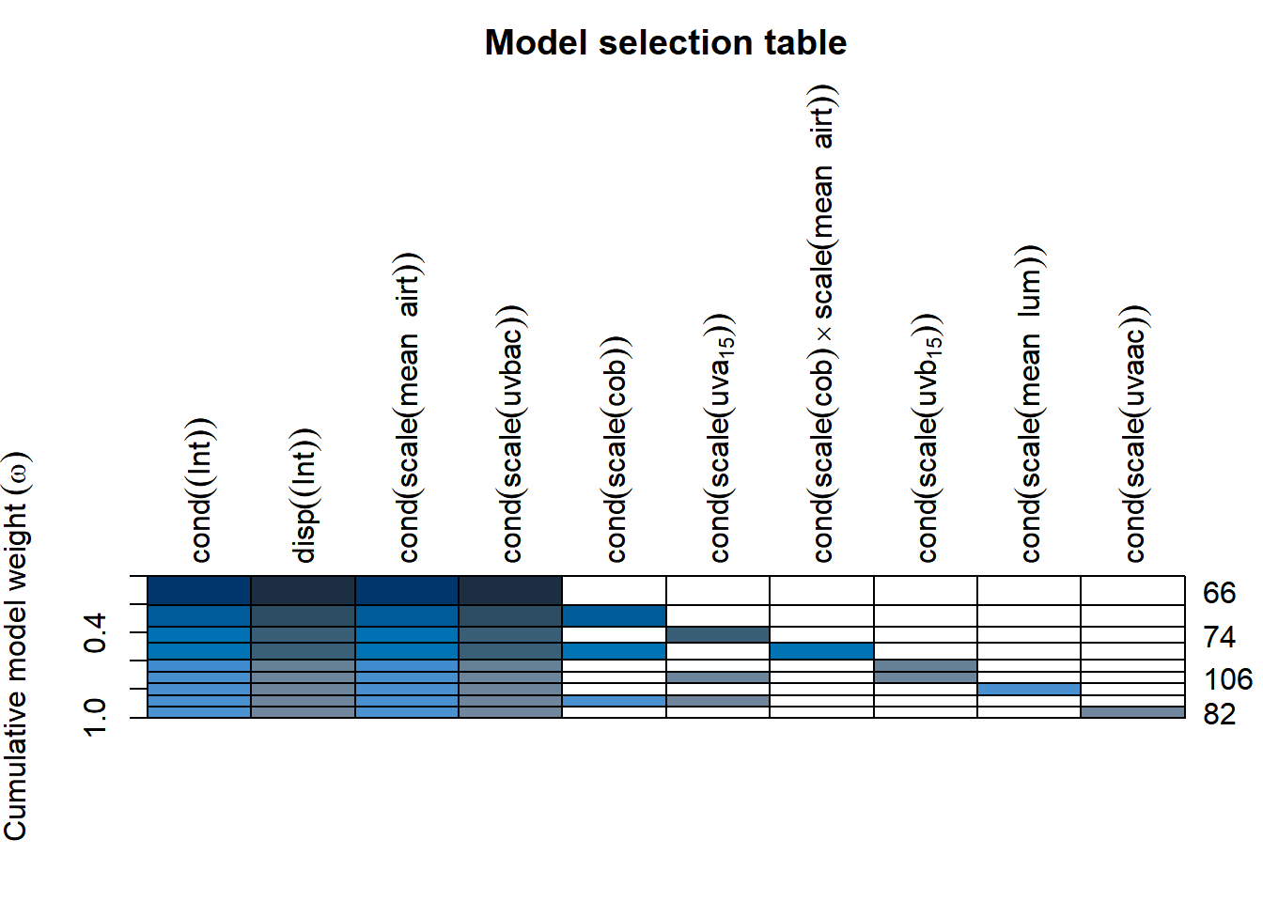

4. Step 4: Model Averaging (provides a consolidated estimate by combining models with AIC<2 obtained in Step 3). Store models that are delta AIC < 2 and average them in a final average model. Model averaging takes into account the uncertainty associated with model selection by assigning weights to each model’s predictions and combining them to obtain a final estimate.
…
# Obtain the average model from models with delta AIC < 2
durcall.model.average <- model.avg(durcall.dredged_model_list, subset = delta < 2, rank = "AIC", fit = TRUE)

# Display summary of the average model
summary(durcall.model.average)
##
## Call:
## model.avg(object = get.models(object = durcall.dredged_model_list,
## subset = delta < 2), rank = "AIC")
##
## Component model call:
## glmmTMB(formula = call_dur_mean ~ <9 unique rhs>, data =
## dados718active, family = gaussian(identity), ziformula = ~0,
## dispformula = ~1)
##
## Component models:
## df logLik AIC delta weight
## 27 8 -1036.99 2089.98 0.00 0.21
## 127 9 -1036.32 2090.64 0.67 0.15
## 1278 10 -1035.53 2091.06 1.08 0.12
## 247 9 -1036.55 2091.10 1.12 0.12
## 267 9 -1036.87 2091.73 1.75 0.09
## 2467 10 -1035.89 2091.79 1.81 0.08
## 1247 10 -1035.90 2091.80 1.82 0.08
## 237 9 -1036.92 2091.85 1.87 0.08
## 257 9 -1036.95 2091.89 1.92 0.08
##
## Term codes:
## cond(scale(cob)) cond(scale(mean_airt))
## 1 2
## cond(scale(mean_lum)) cond(scale(uva15))
## 3 4
## cond(scale(uvaac)) cond(scale(uvb15))
## 5 6
## cond(scale(uvbac)) cond(scale(cob):scale(mean_airt))
## 7 8
##
## Model-averaged coefficients:
## (full average)
## Estimate Std. Error Adjusted SE z value
## cond((Int)) 3.603475 0.285586 0.286038 12.598
## cond(scale(mean_airt)) -0.138349 0.048739 0.048814 2.834
## cond(scale(uvbac)) 0.104163 0.052456 0.052538 1.983
## cond(scale(cob)) -0.014285 0.027947 0.027970 0.511
## cond(scale(cob):scale(mean_airt)) -0.005892 0.020914 0.020928 0.282
## cond(scale(uva15)) 0.012160 0.029360 0.029384 0.414
## cond(scale(uvb15)) -0.005774 0.022079 0.022100 0.261
## cond(scale(mean_lum)) -0.001757 0.017945 0.017970 0.098
## cond(scale(uvaac)) 0.001381 0.017556 0.017582 0.079
## Pr(>|z|)
## cond((Int)) < 2e-16 ***
## cond(scale(mean_airt)) 0.00459 **
## cond(scale(uvbac)) 0.04741 *
## cond(scale(cob)) 0.60955
## cond(scale(cob):scale(mean_airt)) 0.77830
## cond(scale(uva15)) 0.67900
## cond(scale(uvb15)) 0.79389
## cond(scale(mean_lum)) 0.92209
## cond(scale(uvaac)) 0.93741
##
## (conditional average)
## Estimate Std. Error Adjusted SE z value
## cond((Int)) 3.60347 0.28559 0.28604 12.598
## cond(scale(mean_airt)) -0.13835 0.04874 0.04881 2.834
## cond(scale(uvbac)) 0.10416 0.05246 0.05254 1.983
## cond(scale(cob)) -0.04088 0.03388 0.03394 1.204
## cond(scale(cob):scale(mean_airt)) -0.04920 0.03901 0.03907 1.259
## cond(scale(uva15)) 0.04294 0.04150 0.04156 1.033
## cond(scale(uvb15)) -0.03426 0.04378 0.04384 0.781
## cond(scale(mean_lum)) -0.02179 0.05963 0.05972 0.365
## cond(scale(uvaac)) 0.01753 0.06026 0.06035 0.291
## Pr(>|z|)
## cond((Int)) < 2e-16 ***
## cond(scale(mean_airt)) 0.00459 **
## cond(scale(uvbac)) 0.04741 *
## cond(scale(cob)) 0.22841
## cond(scale(cob):scale(mean_airt)) 0.20794
## cond(scale(uva15)) 0.30148
## cond(scale(uvb15)) 0.43453
## cond(scale(mean_lum)) 0.71527
## cond(scale(uvaac)) 0.77143
## ---
## Signif. codes: 0 '***' 0.001 '**' 0.01 '*' 0.05 '.' 0.1 ' ' 1
## --- Pseudo-R² (Pearson) for the best model and model-averaged predictions ---
# 1) Identify and extract the best model (ΔAIC = 0)
best_model.durcall <- get.models(durcall.dredged_model_list, subset = delta == 0)[[1]]

# 2) Generate predictions for the best model (response scale)
pred_best.durcall <- predict(best_model.durcall, type = "response")

# 3) Calculate pseudo-R² (Pearson) for the best model
R2_pseudo_best.durcall <- cor(pred_best.durcall, dados718active$call_dur_mean)^2

# 4) Generate model-averaged predictions (weighted average across models ΔAIC < 2)
pred_avg.durcall <- predict(durcall.model.average, type = "response")

# 5) Calculate pseudo-R² (Pearson) for the averaged model
R2_pseudo_avg.durcall <- cor(pred_avg.durcall, dados718active$call_dur_mean)^2

# 6) Display results
cat("\n------ Pseudo-R² (Pearson) for durcall ------\n")
##
## ------ Pseudo-R² (Pearson) for durcall ------
cat("Best model (ΔAIC = 0): ", round(R2_pseudo_best.durcall, 3), "\n")
## Best model (ΔAIC = 0): 0.523
cat("Averaged model (ΔAIC < 2): ", round(R2_pseudo_avg.durcall, 3), "\n")
## Averaged model (ΔAIC < 2): 0.525
cat("---------------------------------------------\n")
## ---------------------------------------------

5. Step 5: Fitting a Null Model and Comparing It with the Candidate Models

Objective: Fit a null model containing only random effects and temporal autocorrelation, and include it in the candidate model set to compare its AICc, ΔAICc, degrees of freedom, and Akaike weight against the best-supported models.
…
# Fit the null model
# Define the function to fit the null model
fit_null_model_durcall <- function(dados718active) {
glmmTMB(
call_dur_mean ~ 1 +
(1 | site) +
(1 | date) +
ar1(time + 0 | date),
data = dados718active,
family = gaussian(identity)
)
}

# Fit the null model
durcall.null_model <- fit_null_model_durcall(dados718active)

# Diagnostics
diagnose(durcall.null_model)
## Unusually large Z-statistics (|x|>5):
##
## (Intercept) disp~(Intercept) theta_time+0|date.1
## 13.648928 -5.749631 -5.960760
##
## Large Z-statistics (estimate/std err) suggest a *possible* failure of
## the Wald approximation - often also associated with parameters that are
## at or near the edge of their range (e.g. random-effects standard
## deviations approaching 0). (Alternately, they may simply represent
## very well-estimated parameters; intercepts of non-centered models may
## fall in this category.) While the Wald p-values and standard errors
## listed in summary() may be unreliable, profile confidence intervals
## (see ?confint.glmmTMB) and likelihood ratio test p-values derived by
## comparing models (e.g. ?drop1) are probably still OK. (Note that the
## LRT is conservative when the null value is on the boundary, e.g. a
## variance or zero-inflation value of 0 (Self and Liang 1987; Stram and
## Lee 1994; Goldman and Whelan 2000); in simple cases these p-values are
## approximately twice as large as they should be.)
check_convergence(durcall.null_model)
## [1] TRUE
check_singularity(durcall.null_model)
## [1] TRUE
durcall.null_model$sdr$pdHess
## [1] TRUE
# Summary
summary(durcall.null_model)
## Family: gaussian ( identity )
## Formula: call_dur_mean ~ 1 + (1 | site) + (1 | date) + ar1(time + 0 |
## date)
## Data: dados718active
##
## AIC BIC logLik -2*log(L) df.resid
## 2096.0 2123.9 -1042.0 2084.0 769
##
## Random effects:
##
## Conditional model:
## Groups Name Variance Std.Dev. Corr
## site (Intercept) 0.18227 0.4269
## date (Intercept) 0.08646 0.2940
## date.1 time10a 0.19138 0.4375 0.89 (ar1)
## Residual 0.71610 0.8462
## Number of obs: 775, groups: site, 3; date, 19
##
## Dispersion estimate for gaussian family (sigma^2): 0.716
##
## Conditional model:
## Estimate Std. Error z value Pr(>|z|)
## (Intercept) 3.6072 0.2643 13.65 <2e-16 ***
## ---
## Signif. codes: 0 '***' 0.001 '**' 0.01 '*' 0.05 '.' 0.1 ' ' 1
#Extract degrees of freedom (number of parameters)
# Degrees of freedom (K)
df_null.durcall <- attr(logLik(durcall.null_model), "df")
df_null.durcall
## [1] 6
#Include the Full and the Null models in the candidate model set
# Combine null and full models with the selected models (ΔAICc < 2)
durcall.models.with.null.full <- c(
list(null = durcall.null_model, full = durcall.global_m1),
durcall.selected_models
)

# AICc table incluindo o modelo nulo
durcall.AICc.table <- AICctab(durcall.models.with.null.full, weights = TRUE, base=TRUE)

model_summaries.durcall <- lapply(durcall.models.with.null.full, summary)
model_summaries.durcall[["null"]]
## Family: gaussian ( identity )
## Formula: call_dur_mean ~ 1 + (1 | site) + (1 | date) + ar1(time + 0 |
## date)
## Data: dados718active
##
## AIC BIC logLik -2*log(L) df.resid
## 2096.0 2123.9 -1042.0 2084.0 769
##
## Random effects:
##
## Conditional model:
## Groups Name Variance Std.Dev. Corr
## site (Intercept) 0.18227 0.4269
## date (Intercept) 0.08646 0.2940
## date.1 time10a 0.19138 0.4375 0.89 (ar1)
## Residual 0.71610 0.8462
## Number of obs: 775, groups: site, 3; date, 19
##
## Dispersion estimate for gaussian family (sigma^2): 0.716
##
## Conditional model:
## Estimate Std. Error z value Pr(>|z|)
## (Intercept) 3.6072 0.2643 13.65 <2e-16 ***
## ---
## Signif. codes: 0 '***' 0.001 '**' 0.01 '*' 0.05 '.' 0.1 ' ' 1
model_summaries.durcall[["66"]]
## Family: gaussian ( identity )
## Formula:
## call_dur_mean ~ scale(mean_airt) + scale(uvbac) + (1 | site) +
## (1 | date) + (ar1(time + 0 | date))
## Data: dados718active
##
## AIC BIC logLik -2*log(L) df.resid
## 2090.0 2127.2 -1037.0 2074.0 767
##
## Random effects:
##
## Conditional model:
## Groups Name Variance Std.Dev. Corr
## site (Intercept) 0.21847 0.4674
## date (Intercept) 0.06477 0.2545
## date.1 time10a 0.21739 0.4662 0.88 (ar1)
## Residual 0.69632 0.8345
## Number of obs: 775, groups: site, 3; date, 19
##
## Dispersion estimate for gaussian family (sigma^2): 0.696
##
## Conditional model:
## Estimate Std. Error z value Pr(>|z|)
## (Intercept) 3.60257 0.28493 12.644 < 2e-16 ***
## scale(mean_airt) -0.13455 0.04627 -2.908 0.00364 **
## scale(uvbac) 0.10376 0.05138 2.019 0.04346 *
## ---
## Signif. codes: 0 '***' 0.001 '**' 0.01 '*' 0.05 '.' 0.1 ' ' 1
model_formulas.durcall <- lapply(durcall.models.with.null.full, formula)
model_formulas.durcall[["null"]]
## call_dur_mean ~ 1 + (1 | site) + (1 | date) + ar1(time + 0 |
## date)
## <environment: 0x0000016cd16c21c8>
model_formulas.durcall[["66"]]
## call_dur_mean ~ scale(mean_airt) + scale(uvbac) + (1 | site) +
## (1 | date) + (ar1(time + 0 | date))
model_ids.durcall <- intersect(
rownames(durcall.AICc.table),
names(durcall.models.with.null.full)
)

model_formulas.durcall <- sapply(
durcall.models.with.null.full[model_ids.durcall],
function(m) paste(deparse(formula(m)), collapse = " ")
)

model_formulas.durcall
## named list()
AICctab(durcall.models.with.null.full, weights = TRUE, base=TRUE)
## AICc dAICc df weight
## 66 2090.2 0.0 8 0.208
## 67 2090.9 0.7 9 0.146
## 74 2091.3 1.2 9 0.116
## 195 2091.3 1.2 10 0.116
## 98 2092.0 1.8 9 0.085
## 106 2092.1 1.9 10 0.080
## 70 2092.1 1.9 9 0.080
## 75 2092.1 1.9 10 0.080
## 82 2092.1 2.0 9 0.078
## null 2096.1 6.0 6 0.011
## full 2103.2 13.0 17 <0.001
…

The forest plot of the “Full Average” effect sizes of the Average Model. The full average includes all models in the set, regardless of their weights or AIC differences. It provides a weighted average of parameter estimates across all models, considering each model’s weight in the averaging process. Use it when interested in an overall estimate that considers the uncertainty associated with model selection.

See that the effects of air temperature (mean_airt) and cumulative dose UVB (uvbac) do not overlap zero.
# Display summary of the average model
summary(durcall.model.average)
##
## Call:
## model.avg(object = get.models(object = durcall.dredged_model_list,
## subset = delta < 2), rank = "AIC")
##
## Component model call:
## glmmTMB(formula = call_dur_mean ~ <9 unique rhs>, data =
## dados718active, family = gaussian(identity), ziformula = ~0,
## dispformula = ~1)
##
## Component models:
## df logLik AIC delta weight
## 27 8 -1036.99 2089.98 0.00 0.21
## 127 9 -1036.32 2090.64 0.67 0.15
## 1278 10 -1035.53 2091.06 1.08 0.12
## 247 9 -1036.55 2091.10 1.12 0.12
## 267 9 -1036.87 2091.73 1.75 0.09
## 2467 10 -1035.89 2091.79 1.81 0.08
## 1247 10 -1035.90 2091.80 1.82 0.08
## 237 9 -1036.92 2091.85 1.87 0.08
## 257 9 -1036.95 2091.89 1.92 0.08
##
## Term codes:
## cond(scale(cob)) cond(scale(mean_airt))
## 1 2
## cond(scale(mean_lum)) cond(scale(uva15))
## 3 4
## cond(scale(uvaac)) cond(scale(uvb15))
## 5 6
## cond(scale(uvbac)) cond(scale(cob):scale(mean_airt))
## 7 8
##
## Model-averaged coefficients:
## (full average)
## Estimate Std. Error Adjusted SE z value
## cond((Int)) 3.603475 0.285586 0.286038 12.598
## cond(scale(mean_airt)) -0.138349 0.048739 0.048814 2.834
## cond(scale(uvbac)) 0.104163 0.052456 0.052538 1.983
## cond(scale(cob)) -0.014285 0.027947 0.027970 0.511
## cond(scale(cob):scale(mean_airt)) -0.005892 0.020914 0.020928 0.282
## cond(scale(uva15)) 0.012160 0.029360 0.029384 0.414
## cond(scale(uvb15)) -0.005774 0.022079 0.022100 0.261
## cond(scale(mean_lum)) -0.001757 0.017945 0.017970 0.098
## cond(scale(uvaac)) 0.001381 0.017556 0.017582 0.079
## Pr(>|z|)
## cond((Int)) < 2e-16 ***
## cond(scale(mean_airt)) 0.00459 **
## cond(scale(uvbac)) 0.04741 *
## cond(scale(cob)) 0.60955
## cond(scale(cob):scale(mean_airt)) 0.77830
## cond(scale(uva15)) 0.67900
## cond(scale(uvb15)) 0.79389
## cond(scale(mean_lum)) 0.92209
## cond(scale(uvaac)) 0.93741
##
## (conditional average)
## Estimate Std. Error Adjusted SE z value
## cond((Int)) 3.60347 0.28559 0.28604 12.598
## cond(scale(mean_airt)) -0.13835 0.04874 0.04881 2.834
## cond(scale(uvbac)) 0.10416 0.05246 0.05254 1.983
## cond(scale(cob)) -0.04088 0.03388 0.03394 1.204
## cond(scale(cob):scale(mean_airt)) -0.04920 0.03901 0.03907 1.259
## cond(scale(uva15)) 0.04294 0.04150 0.04156 1.033
## cond(scale(uvb15)) -0.03426 0.04378 0.04384 0.781
## cond(scale(mean_lum)) -0.02179 0.05963 0.05972 0.365
## cond(scale(uvaac)) 0.01753 0.06026 0.06035 0.291
## Pr(>|z|)
## cond((Int)) < 2e-16 ***
## cond(scale(mean_airt)) 0.00459 **
## cond(scale(uvbac)) 0.04741 *
## cond(scale(cob)) 0.22841
## cond(scale(cob):scale(mean_airt)) 0.20794
## cond(scale(uva15)) 0.30148
## cond(scale(uvb15)) 0.43453
## cond(scale(mean_lum)) 0.71527
## cond(scale(uvaac)) 0.77143
## ---
## Signif. codes: 0 '***' 0.001 '**' 0.01 '*' 0.05 '.' 0.1 ' ' 1
# Compute confidence intervals for parameters in the fitted average model
confint(durcall.model.average,level = 0.95)
## 2.5 % 97.5 %
## cond((Int)) 3.042851168 4.16409826
## cond(scale(mean_airt)) -0.234022770 -0.04267612
## cond(scale(uvbac)) 0.001189161 0.20713597
## cond(scale(cob)) -0.107389516 0.02563913
## cond(scale(cob):scale(mean_airt)) -0.125776055 0.02737754
## cond(scale(uva15)) -0.038514225 0.12439997
## cond(scale(uvb15)) -0.120188829 0.05166732
## cond(scale(mean_lum)) -0.138835771 0.09526535
## cond(scale(uvaac)) -0.100756042 0.13582148
common_theme <- set_theme(base = theme_bw(),
panel.major.gridcol = FALSE,
panel.minor.gridcol = FALSE,
axis.title.size = 1.1, axis.title.color = "black", axis.title.y.vjust = 3,
axis.textcolor = "black",
plot.margin = margin(0.2, 0.5, 0.5, 0.2, "cm"))

plot1_durcall <- plot_models(durcall.model.average, title = "",
grid = FALSE, dot.size = 2, spacing = 0.6, show.p = TRUE, p.shape = FALSE,
transform = NULL, ci.lvl = 0.95, line.size = 1, show.legend = FALSE,
vline.color = "grey", axis.lim = c(), colors = "bw",
axis.labels = c()) +
common_theme

plot1_durcall
